


SYRIAN SERVICES Hub
A senior 2 project report - submitted to complete the requirements for obtaining a Bachelor’s Degree in informatics engineering

Prepared by
Lilas Nakhal

Supervised by
Eng.Amer Khorheed

Academic Year
2026



منصة السورية الذكية

مشروع تخرج 2 - مُقدَّم لاستكمال متطلبات الحصول على درجة البكالوريوس في هندسة المعلوماتية
قسم البرمجيات ونظم المعلومات

إعداد
ليلاس محمد سامر نخال
إشراف
م. محمد عامر خورشيد

العام الدراسي
2026

SUPERVISION CERTIFICATION

Supervisor Certification I Certify that the preparation of this project entitled
[ Syrian Services Hub]
Prepared by
[Lilas Nakhal]
Were made under our supervision at Faculty of Informatics Engineering in partial Fulfillment of the Requirements for the Degree of Bachelor of Software and Information system Engineering

Name: ………………………………. Name: ………………………………………….

Signature: ……………………………………. Signature: ……………………………….

Abstract

Modern service platforms are no longer limited to displaying services; they are expected to understand user needs and guide them toward the right solution quickly and intelligently. From this perspective, Syrian Services Hub introduces an integrated digital platform that connects users with service providers in an organized, reliable, and user-friendly environment.
The system allows users to create accounts, browse services, search for service providers, request existing services, or post custom service request advertisements when the needed service is not currently available. Users can also receive offers from providers, communicate through the internal chat system, and rate services after completion.
A key feature of the project is the integration of artificial intelligence. Users can describe their problem or need in natural language, and the system suggests suitable solutions while recommending relevant service providers from within the platform. This makes the process of finding the right service smarter and easier.
Service providers can manage their professional profiles, add services, submit offers on user requests, and track their activity through a dashboard that displays statistics, earnings, and ratings. The admin side also provides tools for managing complaints, verification requests, accounts, and platform analytics.
As a result, is not just a service-request platform, but an intelligent digital ecosystem that combines requesting, offering, communication, evaluation, administration, and AI-based recommendations in one place.
In addition to the AI recommendation feature, includes a separate Retrieval-Augmented Generation (RAG) capability named Ask Assistant. An authenticated user can ask a factual question about a selected provider or service, and the system retrieves only active, authorized provider-owned knowledge sources before generating a grounded answer with source citations. When the available evidence is insufficient, the assistant returns a clear insufficient-evidence response rather than inventing information

ملخص

لم تعد منصات الخدمات الحديثة تكتفي بعرض الخدمات فقط، بل أصبحت مطالبة بفهم حاجة المستخدم وتوجيهه نحو الحل المناسب بسرعة وذكاء. ومن هذا المنطلق، يقدم مشروع Syrian Services Hub منصة رقمية متكاملة تربط بين المستخدمين ومزودي الخدمات ضمن بيئة منظمة، موثوقة، وسهلة الاستخدام.
يتيح النظام للمستخدم إنشاء حساب، تصفح الخدمات، البحث عن مزودي الخدمات، طلب خدمة موجودة، أو نشر إعلان عن خدمة يحتاجها في حال لم تكن متوفرة على المنصة. كما يستطيع المستخدم استقبال العروض من مزودي الخدمات، التواصل معهم عبر نظام المحادثة، وتقييم الخدمة بعد الانتهاء منها.
يميز المشروع دمج الذكاء الاصطناعي، حيث يستطيع المستخدم كتابة مشكلته أو حاجته بلغة طبيعية، ليقوم النظام باقتراح حلول مناسبة وترشيح مزودي خدمات من داخل المنصة، مما يجعل تجربة البحث عن الخدمة أكثر ذكاءً وسهولة.
أما مزود الخدمة، فيستطيع إدارة ملفه المهني، إضافة خدماته، تقديم عروض على طلبات المستخدمين، ومتابعة نشاطه من خلال لوحة تحكم تعرض الإحصائيات والأرباح والتقييمات. كما يوفر النظام للأدمن أدوات لإدارة الشكاوى، طلبات التوثيق، الحسابات، ومراقبة أداء المنصة من خلال لوحة تحكم تحليلية.
وبذلك لا تعد مجرد منصة لطلب الخدمات، بل منظومة ذكية تجمع بين الطلب، العرض، التواصل، التقييم، الإدارة، والتوصية الذكية في مكان واحد.
إضافةً إلى ميزة AI Recommendation، تتضمن منصة ميزة مستقلة تعتمد على تقنية التوليد المعزز بالاسترجاع (RAG) . تتيح هذه الميزة للمستخدم المسجل طرح سؤال واقعي حول مزود خدمة أو خدمة محددة

Contents
Section 1 Project Introduction 14
Chapter One: Introduction 15
1.1 Project Overview and Background 15
1.2 Problem Statement and Significance 15
1.3 Project Objectives 16
1.4 Scope, Constraints, and Assumptions 16
1.5 Project Contribution 17
1.6 Research Methodology 18
1.7 Document Structure 18
1.8 Definitions and Key Concepts 19
Chapter Two: Project Development and Management Methodology 20
2.1 Selected Development Methodology and Justification 20
2.2 Project Timeline and Work Plan 20
2.3 Risk Management 21
2.4 Team Roles and Task Distribution 22
2.5 Quality Management in the Project 23
2.6 Project Management Tools Used 23
2.7 Monitoring and Continuous Evaluation Mechanisms 24
2.8 Software Configuration Management 24
Section Two: Theoretical Study and Analysis 25
Chapter Three: Literature Review and Comparative Study 26
3.1 Related Work in Smart and Similar Service Platforms 26
3.2 Modern Technologies and Frameworks in the Domain 26
3.3 Comparative Analysis of Existing Platforms 27
3.4 Research Gap and Proposed Innovation 28
3.5 Theoretical Background and Reference Foundations 29
3.6 Modern and Future Trends in the Domain 29
Chapter Four: Requirements Analysis and Modeling 31
3.7 Retrieval-Augmented Generation for Provider Question Answering 31
4.1 Feasibility Study 31
4.2 Requirements Gathering 32
4.3 Stakeholders and Needs Analysis 32
4.4 Functional Requirements 33
4.5 Non-Functional Requirements 39
4.6 Requirements Prioritization and Management 40
4.7 UML Requirements Modeling 41
4.8 Modeling According to the Selected Methodology 55
4.9 Requirements Analysis and Documentation 57
Section Three: Design and Architecture 65
Chapter Five: System Architecture and Design 66
5.1 High-Level System Design 66
5.2 Database Design 70
5.3 External API Design 74
5.4 Security and Access Design 75
Section Four: Implementation and Testing 77
Chapter Six: Implementation Environment and Tools 78
6.1 Software Tools and Libraries Used 78
6.2 Development Environment and Project Structure 79
6.3 Programming Languages and Frameworks 80
6.4 Database Server and Operating System 81
6.5 Dependencies 81
6.6 Version Control and Source Management Tools 82
6.7 Continuous Integration and Deployment Tools 83
6.8 Testing Environment 83
Chapter Seven: Software Implementation 85
7.1 Project Structure and File Organization 85
7.2 Implementation of Major Functional Modules 86
7.3 API Implementation 87
Request Processing Flow 87
1. Main API Route 88
2. Service Creation Endpoint 88
4. API View Implementation 89
5. Business Rule and Database Creation 90
6. Example Request Body 90
7. Example Response Body 90
7.4 Implementation of the Data-Access Layer 91
7.5 Implementation of the Business-Logic Layer 91
7.6 User Interface Implementation 92
7.7 Implementation of the Intelligent Recommendation-Oriented Functionality 93
7.8 Implementation of Ask Assistant (RAG) 94
Chapter Eight: Testing and Evaluation 96
8.1 Test Plan 96
8.2 Types of Testing 97
8.3 Test Diagrams 98
8.4 Test Results and Analysis 99
8.5 Quality Metrics 109
8.6 Usability Testing 110
8.7 Evaluation Summary 111
Section Five: Results and Recommendations 112
Chapter Nine: Results and Analysis 113
9.1 System Results 113
9.2 Comparative Analysis with Existing Systems 114
9.3 Achievement of Project Objectives 115
9.4 Strengths and Limitations 116
9.5 Key Performance Indicators 116
Chapter Ten: Conclusion and Recommendations 118
10.1 Project Summary and Main Achievements 118
10.2 Difficulties and Challenges 119
10.3 Future Improvements 120
10.4 Recommendations 121
10.5 Closing Statement 122
Section Six: Appendices and References 123
TABLE OF TABLES
table 1 Risk Register 22
table 2Comparative Analysis of Reference Platforms 28
table 3 Stakeholders and Needs Analysis 32
table 4 Functional Requirements 33
table 5 Non-Functional Requirements 39
table 6 Requirements Prioritization 40
table 7 Use Case Descriptions- Submit Complaint 44
table 8 Use Case Descriptions accept or reject offer 44
table 9 Use Case Descriptions submit offer on request 44
table 10 Use Case Descriptions add services 45
table 11 Use Case Descriptions post new request 45
table 12 Increment Plan and User Stories 56
table 13 Story Mapping 56
table 14 Requirements Traceability Matrix 57
table 15 Initial Test Cases-add services 58
table 16 Initial Test Cases send offer 60
table 17 Initial Test Cases post new request 61
table 18 Initial Test Cases sumbit offer on request 62
Table 19 Initial Test Cases Create User Account 63
table 20 Architecture Layer Summary 67
table 21 Core Relational Schema of Syrian Services Hub 71
table 22 Main Database Constraints 72
table 23 Representative API Endpoints 74
table 24 Main software tools and libraries used in the implementation environment 78
table 25 High-level implementation environment structure 79
table 26 Programming languages and frameworks used by the project 80
table 27 Database and execution environment summary 81
table 28 Main dependency groups used by the project 82
table 29 Version control and source-management tools 82
table 30 CI/CD status within the current project scope 83
table 31 Testing environment elements used during implementation 83
table 32 High-level repository structure of Syrian Services Hub 85
table 33 Main implementation modules and their responsibilities 87
table 34 Representative API functions in the implemented system 87
table 35 Data-access responsibilities in the implementation 91
table 36 Representative business-logic responsibilities 92
table 37 Implementation positioning of the recommendation-oriented feature 94
table 38 Test plan overview 96
table 39 Types of testing applied to Syrian Services Hub 97
table 40 Main test cases and validation results add services 101
table 41 Main test cases and validation results submit offer 102
table 42 Main test cases and validation results post new request 103
table 43 Main test cases and validation results submit offer 105
Table 44Main test cases and validation results Create User Account 106
table 45 Quality metrics used in the evaluation 109
table 46 Usability review observations 110
table 47 Comparative analysis between Syrian Services Hub and selected reference platforms. 114
table 48 Achievement of the main project objectives. 115
table 49 Summary of project strengths and limitations. 116
table 50 Suggested KPIs for evaluating Syrian Services Hub. 116
table 51 Summary of main project achievements. 118
table 52 Main project challenges and responses. 120
table 53 Suggested future improvements. 120
table 54 Final recommendations. 121
table 55 Appendix Overview 124

TABLE OF FIGURES
Figure 1 Gantt Chart 21
Figure 2 Main Use Case Diagram for Syrian Services Hub 42
Figure 3 use cae request an exasting service 42
Figure 4 use cae post new request 43
Figure 5 use case submite an offer 43
Figure 6 Post Service Request 47
Figure 7 Activity Diagram - Submit Offer 47
Figure 8 Activity Diagram submit compliant 48
Figure 9 Activity Diagram add services 48
Figure 10 Activity Diagram review incoming offer 49
Figure 11 Sequence Diagram - Submit Offer 50
Figure 12 Sequence Diagram - Submit Offer 51
Figure 13 Sequence Diagram - add services 52
Figure 14 Sequence Diagram -post new request 53
Figure 15 Sequence Diagram -review incoming offer 54
Figure 16 : Sequence Diagram submit complaint 55
Figure 18 System Block Diagram of Syrian Services Hub 67
Figure 19 Architecture of Syrian Services Hub 69
Figure 20 ER Diagram of Syrian Services Hub 70
Figure 21 Placeholder for the project structure 86
Figure 22 Placeholder for a main marketplace interface screenshot. 93
Figure 23 service-request interface screenshot 93
Figure 24 dashboard of Syrian Services Hub. 114

Section 1
Project Introduction

Chapter One: Introduction
This chapter introduces the proposed platform, explains the practical problem it addresses, defines the main objectives of the project, and outlines the intended scope and contribution of the system.

1.1 Project Overview and Background
Syrian Services Hub is a smart digital service marketplace connecting consumers with service providers through a structured platform. It supports visitors, users, providers, and administrators, with functions including service browsing, requests, offers, messaging, verification, and administration. The platform also includes AI Recommendation for suggesting solutions and providers, and Ask Assistant for provider-specific, evidence-based question answering.

1.2 Problem Statement and Significance
Consumers often struggle to find reliable local service providers because services are scattered across social media, personal contacts, and unstructured channels. Providers also face difficulties reaching suitable customers and presenting their services professionally. Syrian Services Hub addresses this gap through a unified marketplace with structured service discovery, requests, offers, communication, and intelligent recommendation support.

1.3 Project Objectives
The project aims to create an accessible and organized marketplace that simplifies service discovery, requests, provider offers, and communication. It also strengthens trust through ratings, complaints, verification, and administrative control. Intelligent support is provided through AI Recommendation for service/provider matching and Ask Assistant for grounded, citation-based answers from authorized provider knowledge.

1.4 Scope, Constraints, and Assumptions
The project covers service browsing, requests, offers, provider profiles, administrative functions, recommendation support, and provider-grounded question answering. Ask Assistant includes knowledge ingestion, chunking, embeddings, retrieval, conversation history, and citations. The main constraints are limited academic time and scope, while users are assumed to have internet access and basic digital literacy.

1.5 Project Contribution
Syrian Services Hub contributes a hybrid local marketplace combining direct service browsing with open service requests and intelligent decision support. AI Recommendation helps users identify suitable solutions and providers, while Ask Assistant introduces grounded, traceable question answering using provider-owned knowledge.

1.6 Research Methodology
The project follows an engineering and descriptive methodology. The engineering aspect covers requirements, architecture, implementation, and evaluation, while the descriptive aspect analyzes current service-discovery challenges and explains how a structured smart platform can address them.

1.7 Document Structure
The thesis progresses from project background and management methodology to related work, requirements analysis, system design, implementation, testing, results, conclusions, future improvements, references, and appendices.

1.8 Definitions and Key Concepts
Key concepts include the service marketplace, visitor, registered user, service provider, administrator, recommendation system, service-demand advertisement, functional and non-functional requirements, RAG, knowledge sources, knowledge chunks, and assistant citations. These concepts define the platform’s operational and intelligent foundations.

Chapter Two: Project Development and Management Methodology
This chapter explains the development methodology adopted for the project, the overall work plan, the main risks and quality considerations, and the mechanisms used to monitor progress and maintain consistency throughout the project lifecycle. It also clarifies how the project was organized from a management perspective in order to support both the technical implementation of the platform and the preparation of its academic documentation.

2.1 Selected Development Methodology and Justification
Syrian Services Hub follows an Incremental Development methodology due to its multiple interconnected modules. The system is developed in manageable increments, allowing each group of features to be designed, implemented, tested, and refined before further functionality is added. This approach supports clear prioritization, controlled integration, and effective delivery within the academic timeframe.

2.2 Project Timeline and Work Plan
The project is organized into five main phases: requirements analysis, system modeling, design, implementation, and testing/documentation. Core modules are developed progressively, followed by validation and final thesis preparation. This structure ensures steady progress while keeping the project manageable and aligned with academic deadlines.

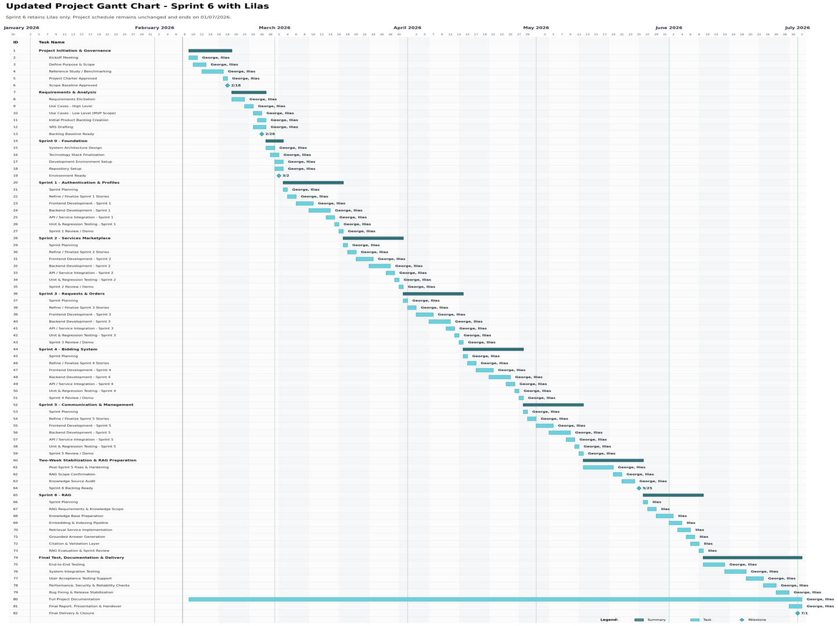

2.3 Risk Management
Key risks include changing requirements, implementation complexity, limited development time, and inconsistencies between analysis, design, and implementation. These risks are reduced through incremental development, regular requirement reviews, prioritization of essential features, and structured documentation.

2.4 Team Roles and Task Distribution
Project tasks are distributed across requirements analysis, system design, modeling, implementation, testing, and documentation. The workflow also considers the integration of the recommendation component with the platform’s core services, ensuring balanced attention to both technical development and academic requirements.

2.5 Quality Management in the Project
Quality management focuses on consistency, reliability, clarity, and alignment between requirements, design, implementation, and documentation. Regular reviews of use cases, system models, and functional relationships help reduce ambiguity and ensure that all platform components, including the recommendation feature, contribute meaningfully to the system.

2.6 Project Management Tools Used
Project management relies on structured documentation, task tracking, organized file management, and version control. These practices help coordinate development and documentation activities, preserve consistency, and reduce the risk of lost or conflicting work.

2.7 Monitoring and Continuous Evaluation Mechanisms
Continuous evaluation is performed through regular reviews of requirements, use cases, system structure, and implementation progress. This allows inconsistencies, missing requirements, and unnecessary complexity to be identified early and corrected before later development stages.

2.8 Software Configuration Management
Software Configuration Management ensures version control, traceability, and consistency across project files, documentation, models, and source code. Organized configuration practices reduce duplication, prevent accidental data loss, and ensure that development remains aligned with the latest approved project version.

Figure 1 Gantt Chart
table 1 Risk Register
Risk ID | Risk Description | Likelihood | Impact | Mitigation Strategy
R-01 | Requirements may change or become clearer during development. | Medium | High | Use iterative review, keep requirements traceable, and prioritize core features.
R-02 | Time limitations may reduce implementation or testing depth. | High | High | Apply phased work planning and focus first on must-have features.
R-03 | Recommendation functionality may become too complex. | Medium | Medium | Keep the first version focused on problem-based suggestions and provider matching.
R-04 | Inconsistency between requirements, design, and implementation. | Medium | High | Use RTM, use cases, and continuous documentation review.
R-05 | Data or diagram updates may affect documentation accuracy. | Medium | Medium | Review models and tables before final submission.

Section

Two: Theoretical Study and Analysis

Chapter Three: Literature Review and Comparative Study
This chapter establishes the theoretical and comparative foundation of Syrian Services Hub by reviewing similar service marketplaces, their operational models, and the features that influenced the proposed system. It also introduces the hybrid marketplace concept and supports later requirements and design decisions.

3.1 Related Work in Smart and Similar Service Platforms
Syrian Services Hub belongs to the domain of digital service marketplaces connecting providers and customers through structured workflows. Benchmark platforms include Khamsat, Mostaql, Fiverr, Upwork, Freelancer, and PeoplePerHour, representing two main models: ready-made services and open service requests with bidding. The proposed system combines key features from these platforms while adapting them to its local and academic context.

3.2 Modern Technologies and Frameworks in the Domain
Modern service platforms rely on scalable web technologies and intelligent support features. React provides responsive interfaces, Django supports backend logic and role-based workflows, PostgreSQL manages relational data, and Postmansupports API testing. Recommendation mechanisms further improve service discovery and user decision-making.

3.3 Comparative Analysis of Existing Platforms
Existing platforms provide different strengths. Khamsat and Fiverr focus on ready-made services, while Mostaqlemphasizes open requests and provider offer. Upwork combines project workflows with messaging, verification, and trust mechanisms, while Freelancer and PeoplePerHour provide useful bidding and hybrid interaction models. Based on this analysis, Syrian Services Hub adopts a hybrid marketplace model combining ready-made services and open service requests in one platform.

table 2Comparative Analysis of Reference Platforms
Platform | Dominant Model | Main Reference Components | Design Role in Syrian Services Hub
Khamsat | Ready-made services | Service, seller profile, ratings, messages | Reference for service listing, browsing, and trust indicators.
Mostaql | Open requests and offers | Project/request, offers, provider selection | Reference for service-demand advertisements and competitive offers.
Fiverr | Gigs / packaged services | Gig page, packages, add-ons | Reference for structured service presentation and clear scope.
Upwork | Hybrid marketplace | Project Catalog, proposals, direct messages, verification | Reference for combining service catalog, requests, messaging, and trust mechanisms.
Freelancer | Bidding and dashboards | Projects, bids, milestones, dashboards | Reference for offer status, provider activity, and dashboard tracking.
PeoplePerHour | Offers and custom projects | Offer, proposal, escrow logic | Reference for coexistence of ready-made offers and custom requests.

3.4 Research Gap and Proposed Innovation
Existing marketplaces provide strong features, but these are often distributed across different platforms. Syrian Services Hub addresses this gap through a hybrid marketplace model that combines ready-made services, open requests, provider comparison, and recommendation support. Its innovation lies in integrating proven marketplace practices into a locally adapted, decision-oriented platform.

3.5 Theoretical Background and Reference Foundations
Syrian Services Hub is based on digital marketplace principles, where users and providers interact through structured workflows for services, requests, offers, communication, trust, and administration. Its hybrid model combines direct service publishing with open service requests, while intelligent recommendations support better user decisions.

3.6 Modern and Future Trends in the Domain
Modern service marketplaces are becoming more intelligent, personalized, and user-centered. Major trends include recommendation systems, responsive interfaces, stronger verification, transparent ratings, complaint management, and improved platform governance. Syrian Services Hub reflects these trends through its hybrid structure, intelligent features, and trust mechanisms.

3.7 Retrieval-Augmented Generation for Provider Question Answering
Retrieval-Augmented Generation (RAG) combines information retrieval with generative AI to produce grounded and traceable answers.
In Syrian Services Hub, Ask Assistant retrieves authorized provider knowledge and generates evidence-based responses with citations. It remains separate from AI Recommendation, which focuses on matching users with suitable services and providers.

Chapter Four: Requirements Analysis and Modeling

4.1 Feasibility Study
Syrian Services Hub is feasible from technical, practical, and academic perspectives. Technically, its core functions can be implemented using modern web technologies supporting role-based access, database-driven workflows, and intelligent features. Practically, it addresses the need for an organized local marketplace connecting users and service providers. Academically, the system provides sufficient scope for requirements analysis, modeling, design, implementation, and testing using software engineering principles.

4.2 Requirements Gathering
System requirements were identified through analysis of the project objectives, stakeholder roles, marketplace workflows, and benchmark platforms. The resulting requirements cover accounts, provider profiles, services, service requests, offers, messaging, ratings, complaints, verification, dashboards, provider comparison, and recommendation support.

4.3 Stakeholders and Needs Analysis
The main stakeholders are visitors, registered users, service providers, and administrators. Each role has specific responsibilities and expectations that are reflected in the system requirements and supported workflows.
table 3 Stakeholders and Needs Analysis
Stakeholder | Main Needs | System Support
Visitor | Browse services before registration and understand available providers. | Public service browsing and basic service/provider information.
Registered User | Request services, post service-demand advertisements, receive offers, compare providers, and get recommendations. | Service request workflow, offer review, messaging, ratings, and recommendation page.
Service Provider | Publish services, manage profile, submit offers, communicate with users, and monitor activity. | Provider profile, service management, offer management, chat, dashboard, and verification request.
Administrator | Control the platform, manage users, review complaints, approve or revoke verification, and monitor statistics. | Admin dashboard, complaint management, verification management, and account control.
Registered User - Ask Assistant | Ask factual questions about a selected provider or service and understand the evidence behind the answer. | Authenticated question submission, grounded answer, source citations, and conversation history.
Service Provider - Knowledge Sources | Upload, list, archive, and reindex customer-facing knowledge sources while controlling what customers may retrieve. | Knowledge-source management, ingestion status, visibility control, and reindex operations.

4.4 Functional Requirements
The functional requirements define the core behaviors that Syrian Services Hub must provide. They represent the main system capabilities required to support both direct service browsing and open service-request workflows. The table below summarizes the key functional requirement groups used in the project. The recommendation requirement and the ability of the administrator to revoke provider verification are included explicitly to keep the requirements aligned with the current system scope.
table 4 Functional Requirements
Requirement ID | Title | Type | Priority | Owner | Description | Acceptance Criteria
AUTH-001 | Create User Account | Functional | High | Visitor | Allows a visitor to create a new user account by entering name, email, and password. | A new record is created in the Users table, and the email address and phone number must be unique.
AUTH-002 | Create Service Provider Account | Functional | High | Visitor | Allows a visitor to register as a service provider by entering name, email, password, and category. | An account with the service provider role is created, and a linked service provider profile is created.
AUTH-003 | Login | Functional | High | User / Provider / Admin | Allows a user, service provider, or admin to log in using email and password. | The credentials are validated, and a valid login session is created.
AUTH-004 | Logout | Functional | Medium | User / Provider / Admin | Allows a user, service provider, or admin to log out of the system. | The current user session is ended.
AUTH-005 | Change Password | Functional | High | User / Provider | Allows a user or service provider to change the password after entering the current password and the new password. | The password is updated in the database after verifying the current password.
PROF-001 | Edit Personal Information | Functional | High | User / Provider | Allows the user to edit personal information such as name, email, phone number, and location. | The user data is successfully updated in the database.
PROV-002 | Edit Service Provider Information | Functional | High | Provider | Allows the service provider to edit professional information such as skills, description, and location. | The service provider data is updated in the Service Providers table.
PROV-003 | View Service Providers | Functional | High | User / Visitor | Allows the user to browse the list of registered service providers and view basic information such as name, rating, and provided services. | Service provider data is retrieved from the database and displayed to the user.
PROV-004 | Compare Service Providers | Functional | Medium | User | Allows the user to select multiple service providers and compare information such as price, rating, execution time, and number of provided services. | A comparison table is displayed containing the selected service providers' information.
SERV-001 | Add Service | Functional | High | Provider | Allows the service provider to add a new service including service name, description, price, and execution duration. | A new service record linked to the service provider is created.
SERV-002 | Edit Service | Functional | High | Provider | Allows the service provider to edit the data of a service that belongs to them. | The service data is updated in the database.
SERV-003 | Delete Service | Functional | High | Provider | Allows the service provider to delete a service they added. | The service is deleted or deactivated in the database.
SERV-004 | View Services | Functional | High | User / Visitor | Allows users to browse the available services on the platform. | Services are retrieved from the database and displayed to the user.
SERV-005 | Search for a Service | Functional | High | User / Visitor | Allows the user to search for services using keywords. | Services matching the search query are displayed.
SERV-006 | Filter Services | Functional | High | User / Visitor | Allows the user to filter services by price, rating, or verified accounts. | Services matching the filter criteria are displayed.
RECO-001 | Recommendation | Functional | High | System / User | Allows the system to provide helpful advice to users and recommend suitable service providers based on the selected service category, request description, provider skills, ratings, location, and service information. | The system displays useful advice and a list of suitable service providers related to the user's request or selected service category.
SERV-007 | Send Request for an Existing Service | Functional | High | User | Allows the user to submit a request for an existing service that was previously added by a service provider. | A new request record is created in the database and linked to the user, service, and service provider, with the status set to Pending.
SERV-008 | Send Offer on Service Request | Functional | High | Provider | Allows the service provider to respond to a service request sent by the user by sending an offer that includes price, duration, or execution details. | A new offer record linked to the service request is created, and the request status is updated to indicate that an offer has been sent.
SERV-009 | Reject Service Request | Functional | High | Provider | Allows the service provider to reject a service request sent by the user. | The request status is updated in the database to Rejected.
SERV-010 | Complete Service | Functional | High | Provider | Allows the service provider to complete the service after finishing its execution for the user. | The service or request status is updated in the database to Completed or Finished successfully.
ORDER-001 | Track Service Request Status | Functional | High | User | Allows the user to track the status of service requests sent to service providers to know whether they are still pending, rejected, or answered with an offer. | The status of each service request is displayed correctly, such as Pending, Rejected, or Offer Sent, and the data is retrieved from the database correctly.
BID-001 | Post New Service Request | Functional | High | User | Allows the user to publish a service request with a service description and expected budget. | A new service request record is created in the database.
BID-002 | Submit Offer on Request Post | Functional | High | Provider | Allows the service provider to submit an offer on the service request post sent by the user. | A new offer record linked to the service request post is created and contains the offer data sent by the service provider.
BID-003 | Edit Offer | Functional | Medium | Provider | Allows the service provider to edit an offer they previously submitted. | The offer data is updated in the database.
BID-004 | Delete Offer | Functional | Medium | Provider | Allows the service provider to delete an offer they submitted. | The offer is deleted or deactivated in the database.
BID-005 | Accept or Reject Offer | Functional | High | User | Allows the user to review the offer sent by the service provider and then accept or reject it. | The selected offer status is updated to Accepted or Rejected according to the user's action.
BID-006 | Track Offer Status | Functional | High | Provider | Allows the service provider to track the status of an offer they sent to know whether it was accepted, rejected, or is still waiting for the user's response. | The status of each offer is displayed correctly for the service provider, such as Pending, Accepted, or Rejected.
BID-007 | Edit Service Request Post | Functional | Medium | User | Allows the user to edit a service request post they previously published before selecting a final offer. | The service request post data is successfully updated in the database.
BID-008 | Delete Service Request Post | Functional | Medium | User | Allows the user to delete a service request post they previously published. | The service request post is deleted or deactivated in the database.
CHAT-001 | Create Conversation | Functional | High | System | The system creates a conversation between the user and the service provider when cooperation starts between them. | A new conversation record is created in the database.
CHAT-002 | Send Message | Functional | High | User / Provider | Allows the user or service provider to send a message within the conversation. | The message is saved in the Messages table.
REV-001 | Rate Service | Functional | High | User | Allows the user to rate the service after completing the request. | A new rating record is created in the database.
REV-002 | Add Comment within Rating | Functional | High | User | Allows the user to add a comment or text note within the rating after completing the service. | The comment is saved successfully with the rating record in the database.
REV-003 | View Rating Comments | Functional | Medium | User / Provider | Allows the system to display comments linked to ratings on the ratings page or in the service provider profile. | Comments linked to ratings are retrieved from the database and displayed correctly.
COMP-001 | Submit Complaint | Functional | High | User | Allows the user to submit a complaint against a service provider. | A complaint record is created with the status Open.
COMP-002 | Manage Complaints | Functional | High | Admin | Allows the admin to review complaints and change their status. | The complaint status can be changed to Under Review, Rejected, or Closed.
VER-001 | Request Service Provider Verification | Functional | High | Provider | Allows the service provider to submit a request to verify their account. | A new verification request is created with the status Pending.
VER-002 | Accept or Reject Verification Request | Functional | High | Admin | Allows the admin to review verification requests and accept or reject them. | The verification request status is updated in the database.
ADMIN-001 | Block and Unblock Accounts | Functional | High | Admin | Allows the admin to block or unblock user and service provider accounts when needed. | The account status is updated in the database to Blocked or Active according to the admin's action.
DASH-P-001 | Service Provider Dashboard | Functional | High | Provider | The dashboard displays information about the service provider's activity, such as completed tasks, average rating, offers, and earnings. | Statistical data is displayed from the database.
DASH-P-002 | Service Provider Earnings Dashboard | Functional | High | Provider | The service provider dashboard displays detailed earnings information, including total earnings, current month earnings, a monthly earnings chart, and average earnings per service. | Total earnings and current month earnings are displayed correctly, a monthly earnings chart is shown, and average earnings per service are calculated and displayed in the dashboard.
DASH-A-001 | Admin Dashboard | Functional | High | Admin | The dashboard displays general platform statistics such as number of users and number of requests. | Data is displayed from the database.
DASH-A-002 | Admin Analytics Dashboard | Functional | High | Admin | The admin dashboard displays platform activity analytics and statistics such as average offer value, offer acceptance rate, most requested category, total number of submitted offers, request distribution by category, and offer status distribution. | Average offer value, offer acceptance rate, and most requested category are displayed correctly, and charts show offer totals, request distribution by category, and offer status distribution.
UI-001 | Multilingual Support | Non-Functional | Medium | System | The system supports Arabic and English languages in the user interface. | The user can change the interface language, and the text is updated across all system pages.
UI-002 | Dark and Light Mode | Non-Functional | Medium | System | Allows the user to switch between dark mode and light mode in the interface. | The selected theme is applied to all system pages and the user's choice is saved.
NFR-001 | Performance and Response Speed | Non-Functional | High | System | The system must respond quickly to user actions while browsing services, searching, sending requests, and submitting offers. | The response time for basic operations must not exceed 3 seconds under normal conditions.
NFR-002 | Availability | Non-Functional | High | System | The system must be available to users, service providers, and admins most of the time without interruption. | The system must achieve at least 99% availability during the operating period.
NFR-003 | Security | Non-Functional | High | System | The system must protect user data, passwords, and sessions from unauthorized access. | Passwords are encrypted, access permissions are verified, and unauthorized access to pages and data is prevented.
NFR-004 | Usability | Non-Functional | Medium | System | The system interfaces must be clear and easy to use for all types of users. | The user can perform basic operations such as registration, search, and sending requests without needing additional explanation.
NFR-005 | Scalability | Non-Functional | Medium | System | The system must support an increase in the number of users, services, and requests without major performance degradation. | The system can handle a noticeable increase in users and requests while maintaining acceptable performance.
NFR-006 | Compatibility with Different Devices | Non-Functional | Medium | System | The system must work correctly on desktops, mobile phones, and tablets. | System pages are displayed correctly on different screen sizes.
RAG-001 | Ask Assistant | Functional | High | User | Allows an authenticated user to ask a factual question about a selected provider or service. The system retrieves relevant evidence only from active, authorized provider-owned knowledge sources and generates a grounded answer. | The system displays an answer with source citations when evidence is sufficient. If evidence is insufficient, it returns a clear insufficient-evidence response and does not invent facts.
RAG-002 | Manage Knowledge Sources | Functional | High | Provider | Allows a provider to upload, list, archive, and reindex customer-facing knowledge sources, while authorized administration can review ingestion status and restricted records. | Source ownership, visibility, ingestion status, and indexing state are stored. Private or archived sources are excluded from customer retrieval.

4.5 Non-Functional Requirements
The non-functional requirements define the quality attributes that the platform must maintain. They support usability, security, performance, availability, scalability, and compatibility across different devices. These requirements guide later design and testing decisions.
table 5 Non-Functional Requirements
Req. ID | Quality Attribute | Priority | Requirement Description | Acceptance Criteria
NFR-001 | Performance | High | The system should respond efficiently during browsing, searching, requesting, and offer submission. | Core operations should respond within an acceptable time under normal conditions.
NFR-002 | Availability | High | The platform should remain available for users, providers, and administrators most of the time. | The system should be accessible during normal operation with minimal interruption.
NFR-003 | Security | High | The system should protect accounts, sessions, passwords, and role-based access. | Passwords are protected, unauthorized access is blocked, and sensitive pages require permission.
NFR-004 | Usability | Medium | The platform should be clear and easy to use for all user roles. | Users can complete essential operations without unnecessary complexity.
NFR-005 | Scalability | Medium | The system should support growth in users, services, requests, and offers. | The design supports additional records and future feature expansion.
NFR-006 | Compatibility | Medium | The interface should work correctly on different screen sizes and devices. | Pages remain readable and usable on desktop, tablet, and mobile screens.
NFR-007 | Groundedness and Privacy | High | Ask Assistant must answer only from authorized active evidence, preserve provider ownership and visibility rules, cite supporting sources, and resist instructions contained inside retrieved documents. | Every supported factual answer includes citations; private, archived, or unrelated sources are excluded; and unsupported questions produce an insufficient-evidence response.

4.6 Requirements Prioritization and Management
The project requirements are prioritized to distinguish the core marketplace functions from supporting and value-adding functions. The MoSCoW method is used to organize requirements into Must Have, Should Have, Could Have, and Won’t Have for the current scope. This helps maintain implementation focus and reduces the risk of unnecessary scope expansion.
table 6 Requirements Prioritization
Priority | Included Requirements | Reason
Must Have | Authentication, service management, service requests, offers, messaging, complaint handling, verification, recommendation feature. | These requirements form the operational core of the platform.
Should Have | Ratings, comments, dashboards, provider comparison, search and filtering improvements. | They improve trust, decision-making, and user experience.
Could Have | Advanced analytics, expanded recommendation criteria, automated moderation, notification enhancements. | They add value but can be implemented progressively.
Won’t Have Now | Online payment integration, mobile application, advanced AI chatbot, external platform integration. | They are outside the current academic project scope.
Must Have | Ask Assistant (RAG), provider knowledge-source management, permission-aware retrieval, answer citations, and insufficient-evidence handling. | These requirements are necessary for safe, traceable, evidence-based customer question answering.

4.7 UML Requirements Modeling
UML requirements modeling provides a visual representation of the system’s main behaviors and interactions. Since Syrian Services Hub includes several actors and interconnected workflows, UML models are necessary to clarify how users, providers, visitors, and administrators interact with the system. The most important UML artifacts in this chapter include use case diagrams, use case descriptions, activity diagrams, and sequence diagrams.

4.7.1 Main Use Case Diagrams
The main use case diagram should present the primary actors and the most important system interactions. It should focus on the functional core instead of listing every minor operation. For this project, the diagram should include Visitor, User, Service Provider, and Administrator as the main actors. The key use cases should include browsing services, posting a service request, submitting an offer, accepting or rejecting an offer, managing services, managing complaints, managing verification, revoking verification, and getting problem-based recommendations.
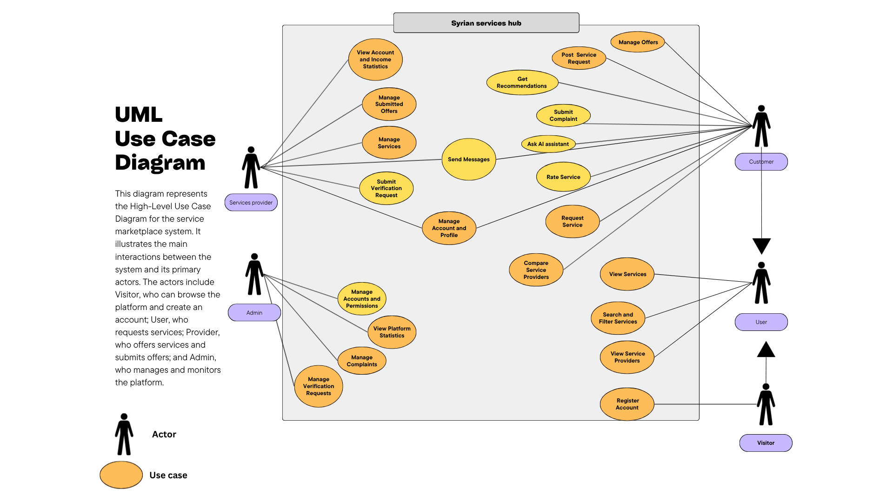

4.7.2 Use Case Descriptions
Use case descriptions explain the most important interactions in a structured textual form. Each description identifies the actor, objective, preconditions, main flow, exceptional flow, and postconditions. The table below summarizes the main use cases selected for the analysis chapter.
table 7 Use Case Descriptions- Submit Complaint
Field | Description
Use Case ID | COMP-001
Use Case Name | Submit Complaint
Actors | User
Goal | Enable the user to submit a complaint against a service provider.
Preconditions | 1. The user is logged in. 2. There has been a previous interaction with the service provider.
Main Flow | 1. System: Displays the “Submit Complaint” option and the complaint form. 2. User: Enters the complaint details and clicks “Submit”. 3. System: Verifies that the complaint is not empty, then creates a new complaint record with the status “Open”. 4. User: Returns to the previous page or the complaints page. 5. System: Displays the new complaint status and shows a success message.
Exceptional Flows | EF1: The complaint details are empty or invalid.
Postconditions | A complaint record is created with the status “Open”.
table 8 Use Case Descriptions accept or reject offer
Field | Description
Use Case ID | BID-005
Use Case Name | Accept or Reject Offer
Actors | User
Goal | Enable the user to review the offer submitted by the service provider and then accept or reject it.
Preconditions | 1. The user is logged in. 2. There is an offer submitted on a request or announcement that belongs to the user.
Main Flow | 1. System: Displays the list of offers received on the user’s requests or announcements. 2. User: Reviews a specific offer and clicks “Accept” or “Reject”. 3. System: Updates the status of the selected offer according to the user’s action. 4. User: Returns to the offers list or opens the offer details. 5. System: Displays the updated offer status and shows a success message.
Exceptional Flows | EF1: The offer has already been processed or is no longer available.
Postconditions | The offer status is updated to “Accepted” or “Rejected”.
table 9 Use Case Descriptions submit offer on request
Field | Description
Use Case ID | UC-22
Use Case Name | Submit Offer on Request
Actors | Provider
Goal | Enable the service provider to submit an offer on a service request posted by the user.
Preconditions | 1. The service provider is logged in. 2. There is an available service request that can receive offers.
Main Flow | 1. System: Displays the list of available service requests. 2. Provider: Selects a request, enters the offer details, and clicks the “Submit Offer” button. 3. System: Validates the entered data and creates a new offer record linked to the service request. 4. Provider: Moves to the provider’s offers list. 5. System: Displays the new offer and shows a success message.
Exceptional Flows | EF1: The request is not available, or the offer data is invalid.
Postconditions | A new offer record is created and linked to the service request.
table 10 Use Case Descriptions add services
Field | Description
Use Case ID | SERV-001
Use Case Name | Add Service
Actors | Provider
Goal | Enable the service provider to add a new service.
Preconditions | 1. The service provider is logged in. 2. The Add Service page is available.
Main Flow | 1. System: Displays the Add Service form, including name, description, price, and execution duration. 2. Provider: Enters the service details and clicks the “Save” button. 3. System: Validates that all required data is completed and that the price and execution duration are valid. 4. Provider: Confirms the operation. 5. System: Creates a new service record linked to the provider and displays a success message.
Exceptional Flows | EF1: The data is incomplete, or the price/execution duration is invalid.
Postconditions | A new service record is created and linked to the service provider.
table 11 Use Case Descriptions post new request
Field | Description
Use Case ID | UC-21
Use Case Name | Post New Request
Actors | User
Goal | Enable the user to post a service request announcement with a service description and expected budget.
Preconditions | 1. The user is logged in. 2. The Post New Request page is available.
Main Flow | 1. System: Displays the Post New Request form. 2. User: Enters the service description and expected budget, then clicks the “Post Request” button. 3. System: Validates that the data is complete and that the budget is valid, then creates a new service request record. 4. User: Moves to the user’s requests page or continues browsing. 5. System: Displays the new request in the user’s request list and shows a success message.
Exceptional Flows | EF1: The budget or entered data is invalid.
Postconditions | A new service request record is created in the database.

4.7.3 Activity Diagrams
Activity diagrams describe the workflow of major processes step by step. They are useful for representing decisions, validations, and outcomes in operations that include multiple stages. In this project, the recommended activity diagrams are related to posting a service request, submitting an offer, accepting or rejecting an offer
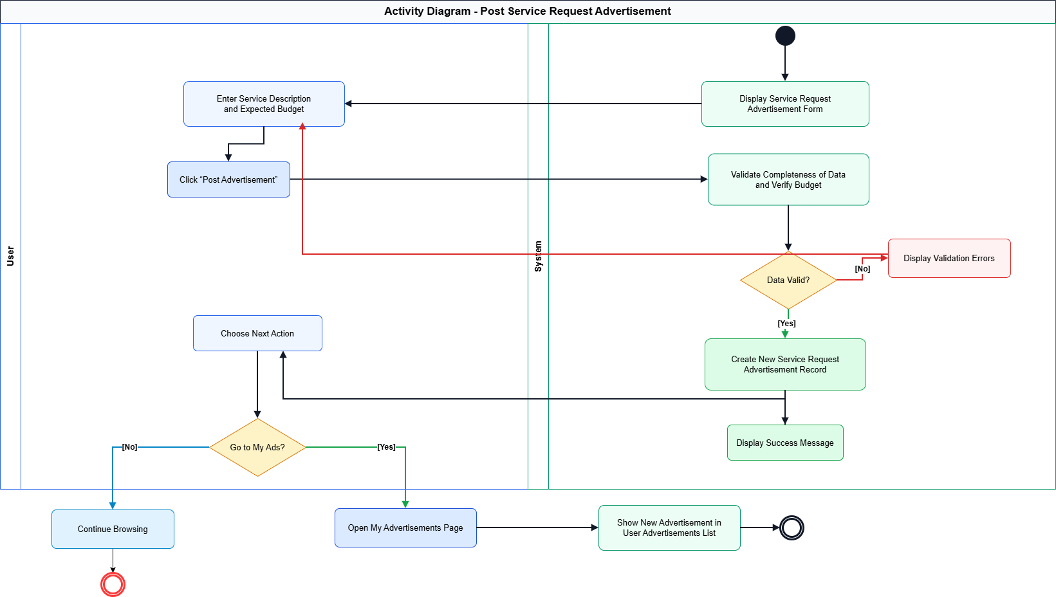Figure 6 Post Service Request

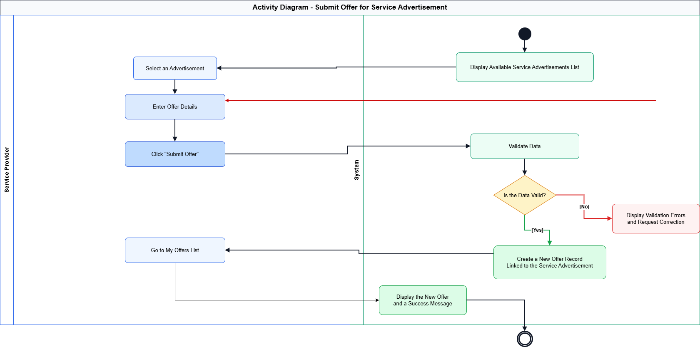Figure 7 Activity Diagram - Submit Offer
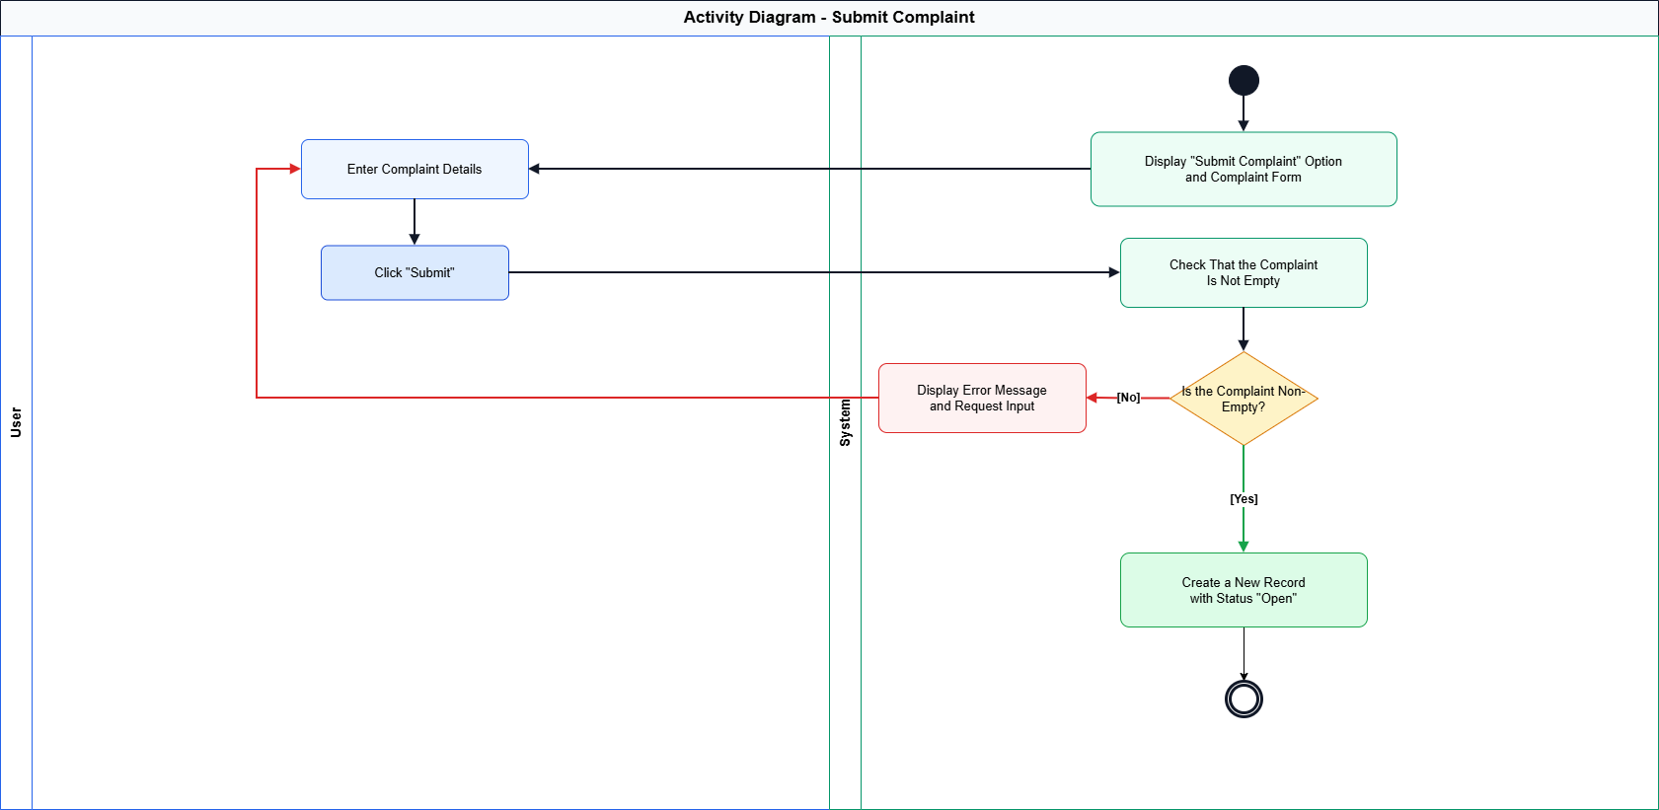
Figure 8 Activity Diagram submit compliant

4.7.4 Sequence Diagrams
Sequence diagrams show the chronological interaction between actors and system components during the execution of major use cases. They are especially useful for clarifying how requests move between the user interface, the application logic, and the database layer. The following placeholders should be replaced with the final sequence diagrams.
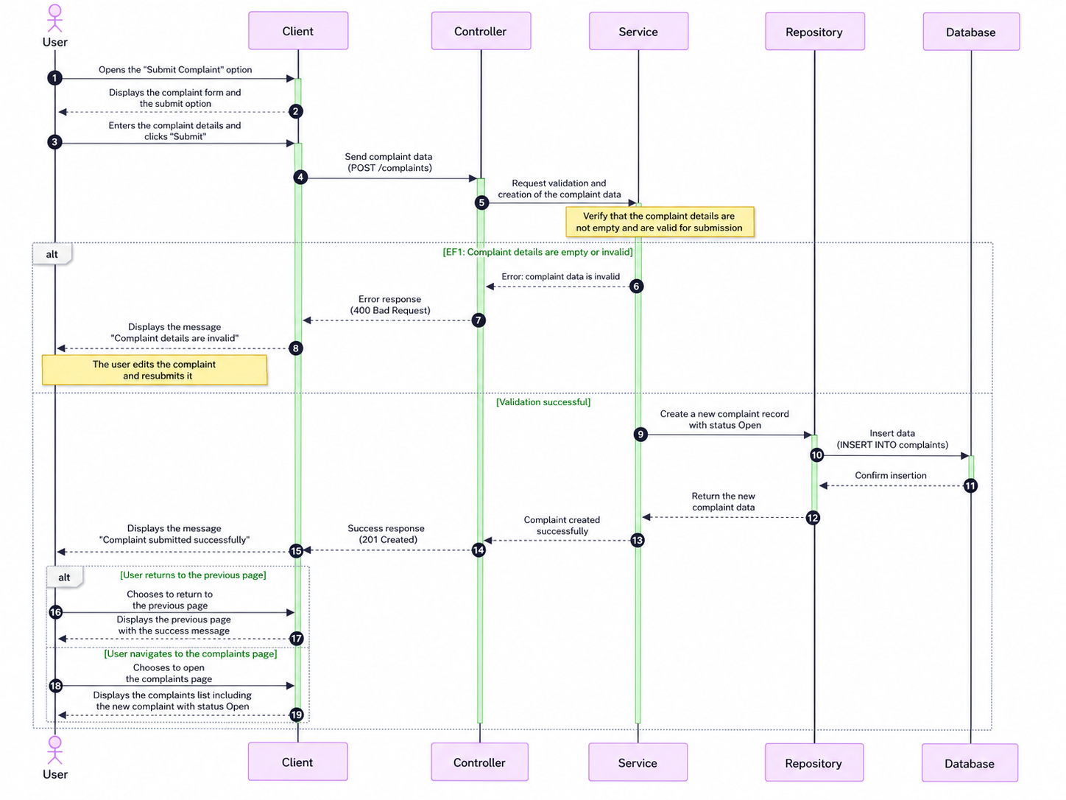
Figure 11 Sequence Diagram - Submit Offer
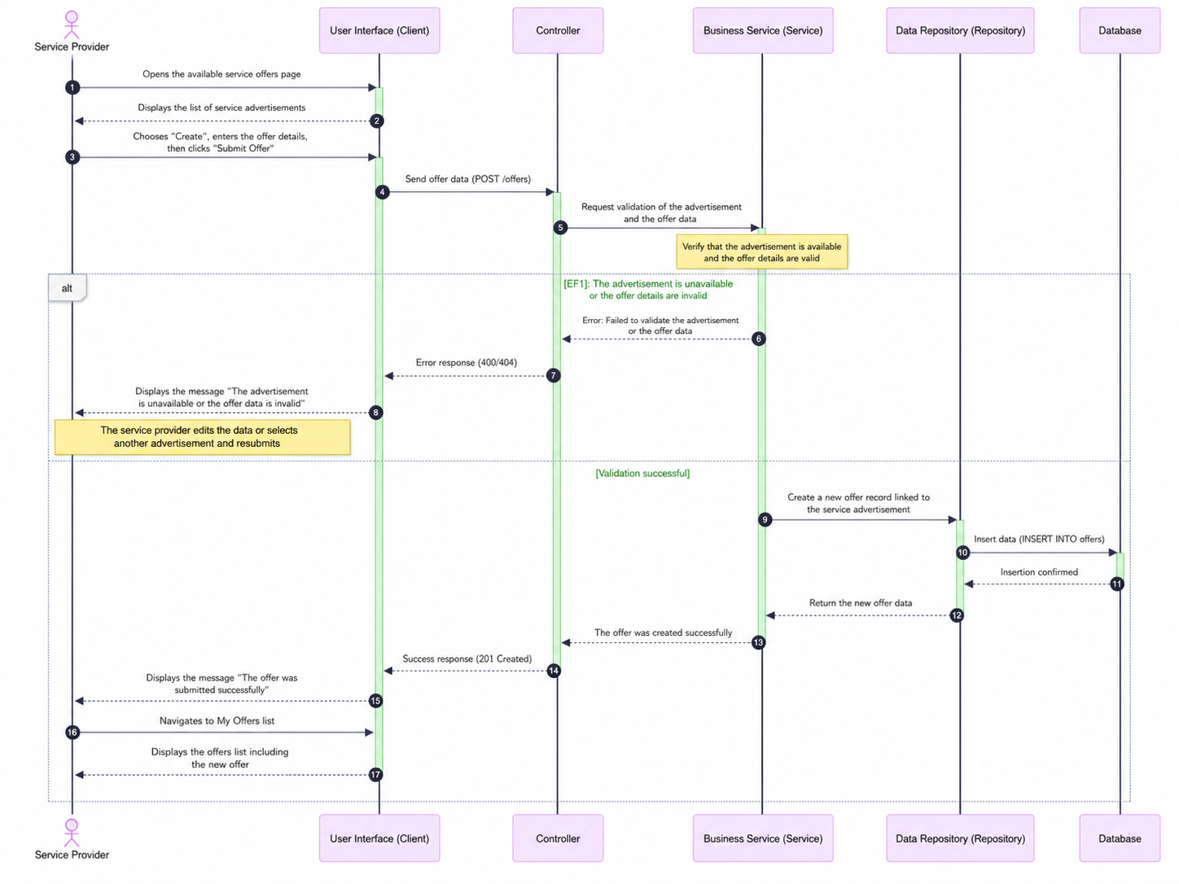
Figure 12 Sequence Diagram - Submit Offer
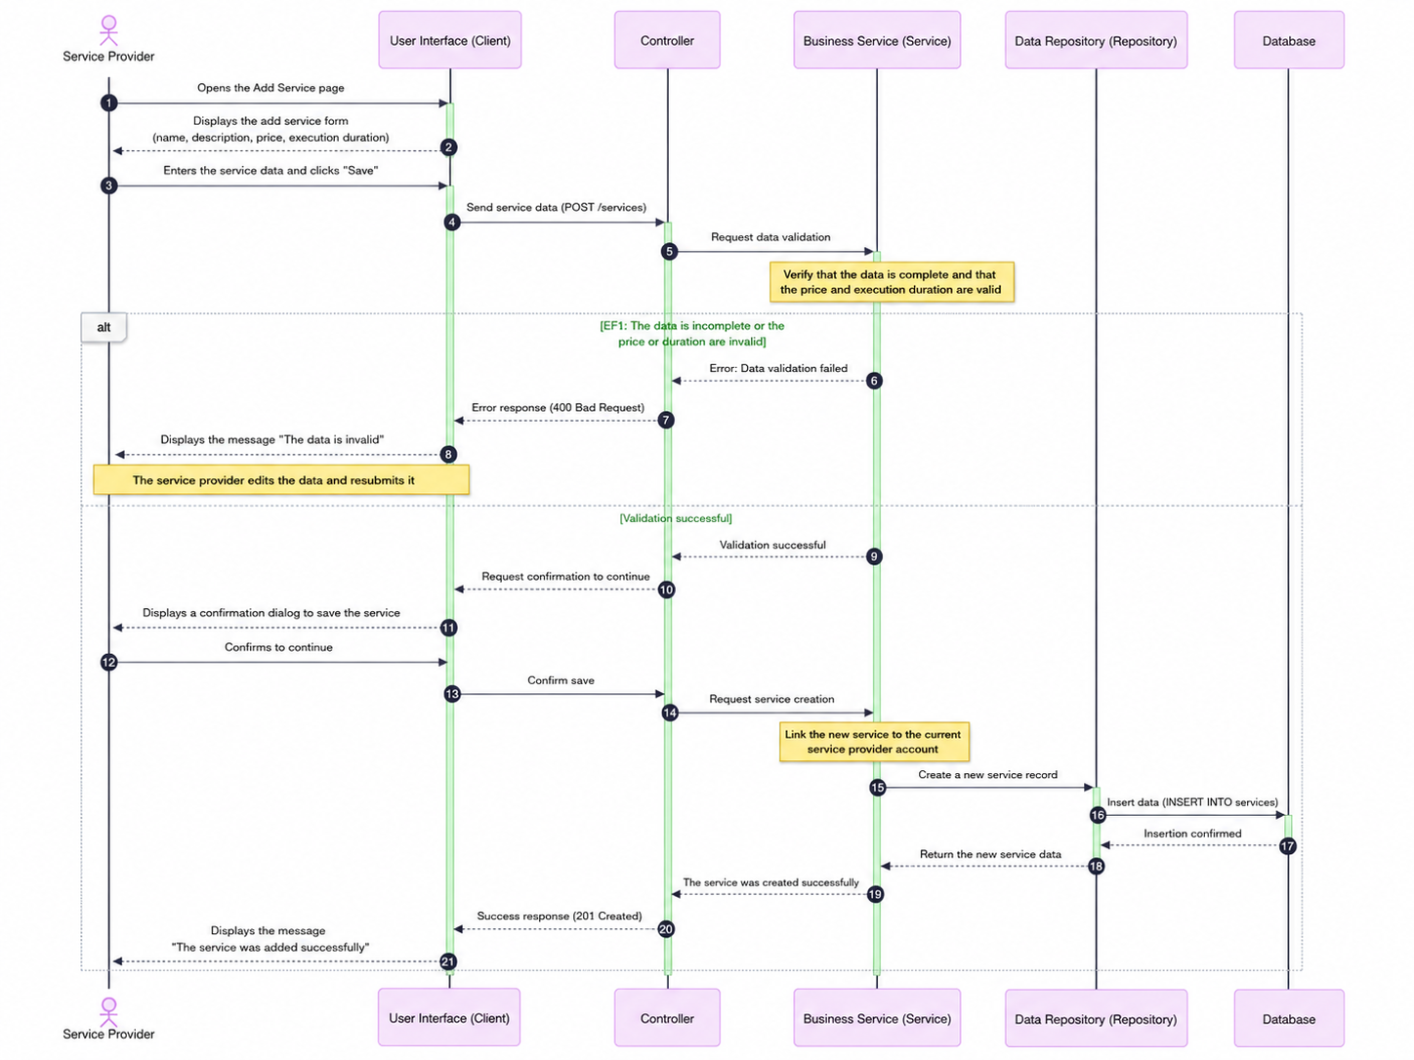
Figure 13 Sequence Diagram - add services
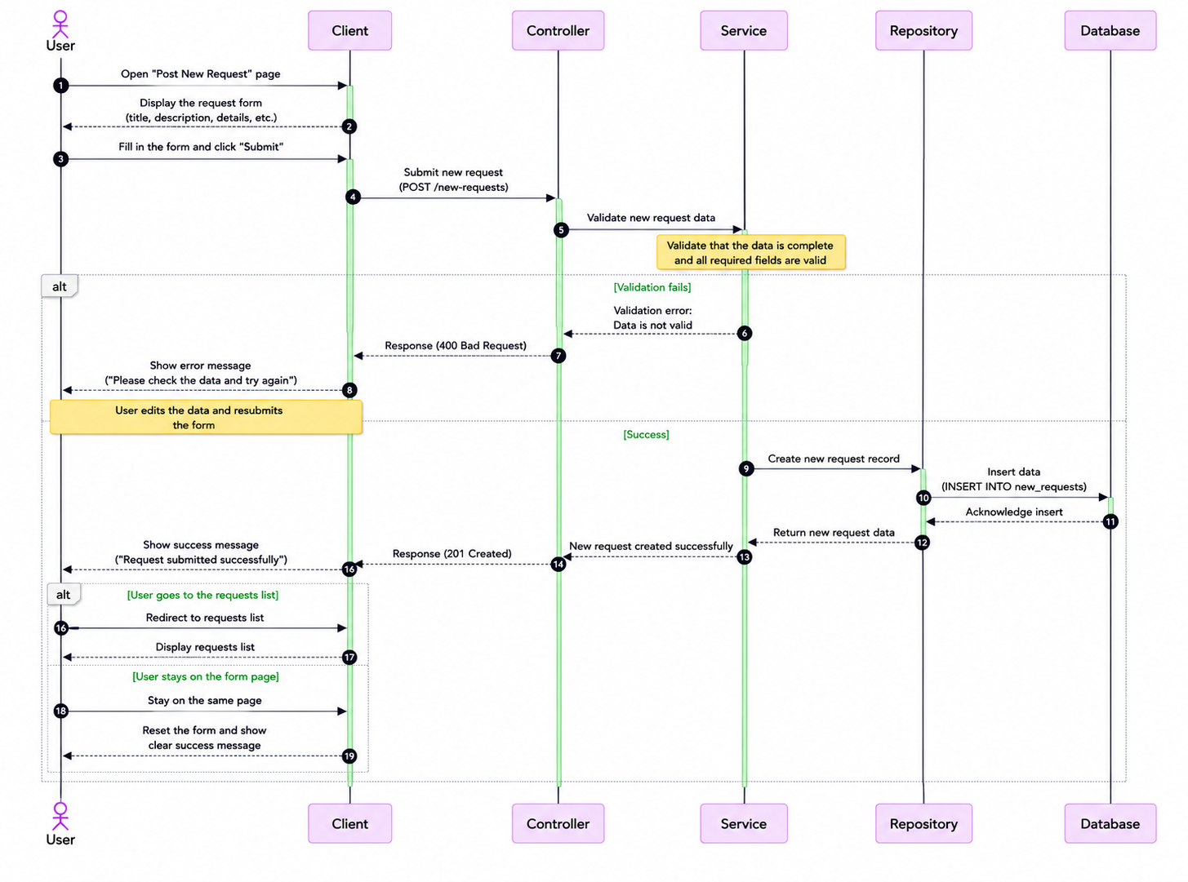
Figure 14 Sequence Diagram -post new request

4.8 Modeling According to the Selected Methodology
Since Syrian Services Hub uses Incremental Development, the requirements are organized into prioritized increments that deliver usable capabilities progressively. The supporting artifacts include user stories, an increment plan, acceptance criteria, dependency awareness, and review outputs for each completed increment. This form of modeling complements UML diagrams by showing how requirements are grouped into coherent deliveries, validated after implementation, and extended in later increments without losing traceability.

4.8.1 Increment Plan and User Stories
table 12 Increment Plan and User Stories
Story ID | User Story | Priority | Acceptance Focus
US-01 | As a visitor, I want to browse services so that I can explore the platform before registering. | Must | Services are displayed without requiring login.
US-02 | As a user, I want to post a service request so that providers can submit offers. | Must | A request is created and visible to eligible providers.
US-03 | As a provider, I want to publish services so that users can request them directly. | Must | A service is created and linked to the provider profile.
US-04 | As a provider, I want to submit offers on user requests so that I can compete for work. | Must | An offer is saved and linked to the selected request.
US-05 | As a user, I want to compare providers so that I can select the most suitable one. | Should | Provider data is displayed in a comparison view.
US-06 | As a user, I want to enter a problem and receive suggested solutions and a provider. | Must | The system displays solution suggestions and a recommended provider.
US-07 | As an admin, I want to revoke provider verification so that trust violations can be handled. | Must | The provider verification status changes to unverified and the action is logged.
US-08 | As an authenticated user, I want to ask a factual question about a selected provider or service so that I can receive a grounded answer with source citations. | Must | Ask Assistant returns a cited answer from authorized evidence or a clear insufficient-evidence response.
US-09 | As a provider, I want to manage customer-facing knowledge sources so that Ask Assistant can answer from current and approved information. | Must | The provider can upload, view status, archive, and reindex owned sources without exposing private content.

4.8.2 Story Mapping
The story map groups the main user activities into meaningful workflow areas. This helps present the project as a set of connected journeys rather than isolated requirements.
table 13 Story Mapping
User Journey Area | Main Activities | Representative Stories
Service Discovery | Browse, search, filter, view service details. | US-01, SERV-004, SERV-005, SERV-006
Service Request Flow | Post request, receive offers, accept or reject offers. | US-02, BID-001, BID-002, BID-005
Provider Workflow | Manage profile, publish services, submit offers, follow offer status. | US-03, US-04, PROV-002, BID-006
Trust and Governance | Ratings, complaints, verification, revoke verification. | REV-001, COMP-001, VER-001, VER-003
Intelligent Support | Enter problem, analyze content, suggest solutions and provider. | US-06, RS-001
Knowledge-Based Assistance | Ask provider-specific questions, retrieve authorized evidence, generate a grounded answer, display citations, and preserve conversation history. | US-08, US-09, RAG-001, RAG-002

4.9 Requirements Analysis and Documentation
Requirements analysis and documentation aim to ensure that every major requirement remains clear, justified, and traceable through later stages of design and testing. The following traceability matrix links representative requirements to their related design artifacts and initial validation methods.

4.9.1 Requirements Traceability Matrix
table 14 Requirements Traceability Matrix
Req ID (Mapped FR IDs) | User Story | Use Cases | Analysis | Detailed design | coding | test cases
SERV-001 | US-01 | UC-01 | an-01 | de-01 | im-01 | tc-01
SERV-008 | US-02 | UC-02 | an-02 | de-02 | im-03 | tc-02
BID-001 | US-03 | UC-03 | an-03 | de-03 | im-04 | tc-03
BID-002 | US-04 | UC-04 | an-04 | de-04 | im-05 | tc-04
AUTH-001 | US-05 | UC-05 | an-05 | de-05 | im-05 | tc-05
RAG-001 / RAG-002 | US-08 / US-09 | UC-08 | AN-08 | DE-08 | IM-08 | TC-08

4.9.2 Initial Test Cases
Initial test cases provide an early bridge between requirement analysis and later verification. They do not replace the full testing chapter, but they show how the most important requirements can be translated into observable system behavior.
table 15 Initial Test Cases-add services
Test Case ID | TC-SERV-001 | Requirement Ref. | SERV-001
Use Case Ref. | UC-10 | Module | Services
Title | Add Service | Owner / Actor | Provider
Test Type | Functional / Positive | Test Level | System
Priority | High | Severity | High
Risk Level | High | Automation Candidate | Medium
Objective | Verify that the system satisfies the Add Service requirement according to the defined main scenario. | Design Technique | Use Case Based
Description |  | Allows the service provider to add a new service that includes service name, description, price, and execution duration.
Pre-conditions |  | The required actor is logged in.  The Add Service page is available.
Test Data / Input |  | Service Name: AC Maintenance  Price: 150  Execution Duration: Two days
Test Steps |  | Open the screen or section related to the "Add Service" feature.  Enter or select valid test data when needed.  Execute the main action related to the feature.  Review the result displayed to the user or actor.  Verify that the change is saved or data is retrieved from the database according to the expected behavior.
Expected Result |  | A new service record linked to the service provider is created.  No unexpected error messages or behavior that conflicts with the scenario appear.  The interface or data is updated according to the performed operation.
Post-conditions |  | A new service record linked to the service provider is created.
Exception Notes |  | There are no additional exception notes for this baseline case; other scenarios are covered in later test cases.
Actual Result |  | Execution Status | ☐ Pass ☐ Fail ☐ Blocked ☐ N/A
Defect Reference | ................................ | Executed By | ................................
Reviewed By | ................................ | Date Created | 2026-03-10
Execution Date | ................................ | Remarks / Notes | These fields are used during actual execution by the testing team.

table 16 Initial Test Cases send offer
Test Case ID | TC-SERV-008 | Requirement Ref. | SERV-008
Use Case Ref. | UC-17 | Module | Orders
Title | Send Offer on Service Request | Owner / Actor | Provider
Test Type | Functional / Positive | Test Level | System
Priority | High | Severity | High
Risk Level | High | Automation Candidate | Medium
Objective | Verify that the system satisfies the Send Offer on Service Request requirement according to the defined main scenario. | Design Technique | Use Case Based
Description |  | Allows the service provider to respond to the service request sent by the user by submitting an offer that includes price, duration, or execution details.
Pre-conditions |  | The required actor is logged in.  An incoming service request with Pending status exists.
Test Data / Input |  | Proposed Price: 120  Proposed Duration: 2 days  Execution Details: Visit and inspection
Test Steps |  | Open the screen or section related to the "Send Offer on Service Request" feature.  Enter or select valid test data when needed.  Execute the main action related to the feature.  Review the result displayed to the user or actor.  Verify that the change is saved or data is retrieved from the database according to the expected behavior.
Expected Result |  | A new offer record linked to the service request is created, and the request status is updated to indicate that it has been answered with an offer.  No unexpected error messages or behavior that conflicts with the scenario appear.  The interface or data is updated according to the performed operation.  In the exceptional scenario: the offer data is invalid or the request is no longer Pending.
Post-conditions |  | A new offer record linked to the service request is created, and the request status is updated to indicate that it has been answered with an offer.
Exception Notes |  | The offer data is invalid or the request is no longer Pending.
Actual Result |  | Execution Status | ☐ Pass ☐ Fail ☐ Blocked ☐ N/A
Defect Reference | ................................ | Executed By | ................................
Reviewed By | ................................ | Date Created | 2026-03-10
Execution Date | ................................ | Remarks / Notes | These fields are used during actual execution by the testing team.

table 17 Initial Test Cases post new request
Test Case ID | TC-BID-001 | Requirement Ref. | BID-001
Use Case Ref. | UC-21 | Module | Bidding
Title | Post New Request | Owner / Actor | User
Test Type | Functional / Positive | Test Level | System
Priority | High | Severity | High
Risk Level | High | Automation Candidate | Medium
Objective | Verify that the system satisfies the Post New Request requirement according to the defined main scenario. | Design Technique | Use Case Based
Description |  | Allows the user to post a service request with a service description and expected budget.
Pre-conditions |  | The required actor is logged in.  The Post New Request page is available.
Test Data / Input |  | Description: Installing an electrical network  Expected Budget: 500
Test Steps |  | Open the screen or section related to the "Post New Request" feature.  Enter or select valid test data when needed.  Execute the main action related to the feature.  Review the result displayed to the user or actor.  Verify that the change is saved or data is retrieved from the database according to the expected behavior.
Expected Result |  | A new service request record is created in the database.  No unexpected error messages or behavior that conflicts with the scenario appear.  The interface or data is updated according to the performed operation.
Post-conditions |  | A new service request record is created in the database.
Exception Notes |  | There are no additional exception notes for this baseline case; other scenarios are covered in later test cases.
Actual Result |  | Execution Status | ☐ Pass ☐ Fail ☐ Blocked ☐ N/A
Defect Reference | ................................ | Executed By | ................................
Reviewed By | ................................ | Date Created | 2026-03-10
Execution Date | ................................ | Remarks / Notes | These fields are used during actual execution by the testing team.

Section Three: Design and Architecture

Chapter Five: System Architecture and Design

This chapter explains how the analyzed requirements of Syrian Services Hub are transformed into a structured technical design. It presents the architectural vision of the platform, the logic behind its main components, and the way system functionality is distributed across the application structure. The chapter also covers database design, API-oriented interaction, and security considerations. In this way, the chapter serves as the bridge between requirements analysis and implementation by showing how the system is planned to operate from a software engineering perspective.

5.1 High-Level System Design
The high-level design of Syrian Services Hub focuses on organizing the platform into clear functional layers and modules that support service discovery, service-demand advertisements, offer management, communication, trust-related operations, and recommendation support. At this level, the design aims to ensure maintainability, separation of concerns, and a coherent interaction between the client interface, the backend application logic, and the underlying data storage.

5.1.1 System Block Diagram
The system block diagram presents the main components of the platform and the communication paths between them. It should show the user-facing client side, the server-side application logic, the database layer, and the recommendation-related module. The figure is intended to summarize the overall structure of the platform before moving into more detailed architectural explanation.

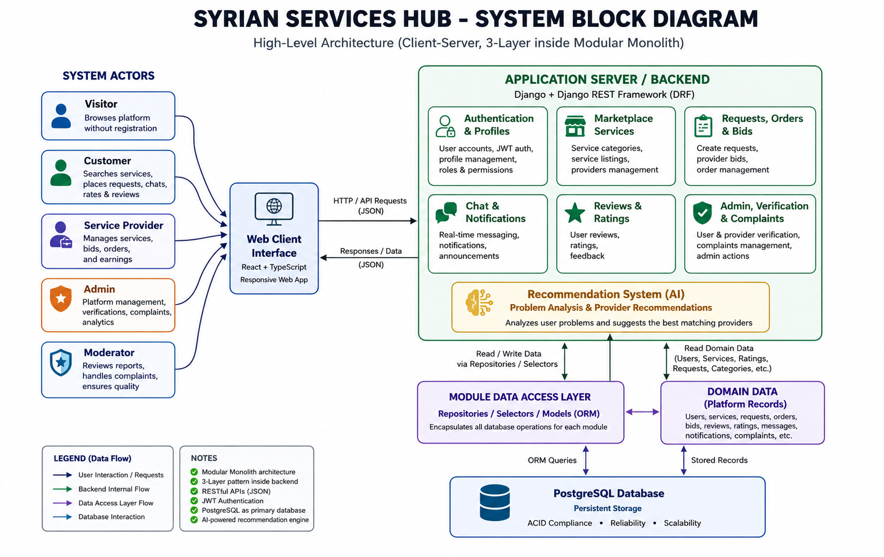
Figure 17 System Block Diagram of Syrian Services Hub

5.1.2 Architectural Pattern Used
Syrian Services Hub follows a client-server architecture implemented through a three-tier design pattern. This architectural pattern was selected because it provides clear separation between the presentation layer, the application or business logic layer, and the data layer. Such separation is well suited to a web-based platform that must support multiple user roles, structured service workflows, and recommendation-oriented processing while remaining maintainable and scalable.
table 20 Architecture Layer Summary
Layer | Main Responsibility | Technology Direction
Presentation Layer | Provides the user interface for visitors, users, providers, and administrators; supports browsing, requests, offers, dashboards, and recommendation interaction. | React-based web interface
Business Logic Layer | Handles workflows, validation, role-based operations, recommendation processing, notifications, complaints, and verification management. | Django application logic and REST endpoints
Data Layer | Stores persistent platform records such as users, services, requests, offers, messages, complaints, ratings, and verification data. | PostgreSQL relational database

5.1.3 System Architecture Design
Syrian Services Hub follows a three-layer architecture: presentation, business logic, and data. The presentation layer manages role-based interfaces, the business logic layer handles workflows, authorization, and intelligent processing, and the data layer stores persistent relational data.
AI Recommendation analyzes user needs to suggest suitable services and providers, while Ask Assistant uses RAG to answer provider-specific questions from authorized knowledge sources.

5.1.4 Ask Assistant RAG Architecture
Ask Assistant operates through the knowledge and customer_assistant modules. The knowledge module manages sources, chunks, embeddings, and retrieval, while customer_assistant manages sessions, questions, answers, and citations.
Authorized documents are validated, chunked, embedded, and indexed. During retrieval, access controls are applied before relevant evidence is selected for answer generation. The system follows a grounding-first security model, excluding unauthorized content and returning an insufficient-evidence response when reliable information is unavailable.

5.2 Database Design
The system uses a relational database model to maintain consistency across users, providers, services, requests, offers, messages, ratings, complaints, verification records, and administrative activities.

5.2.1 Entity Relationship Model
The Entity Relationship Model defines the relationships among the platform’s main entities, including users, provider profiles, services, requests, offers, conversations, messages, ratings, complaints, and verification requests, supporting both direct services and request-and-offer workflows.
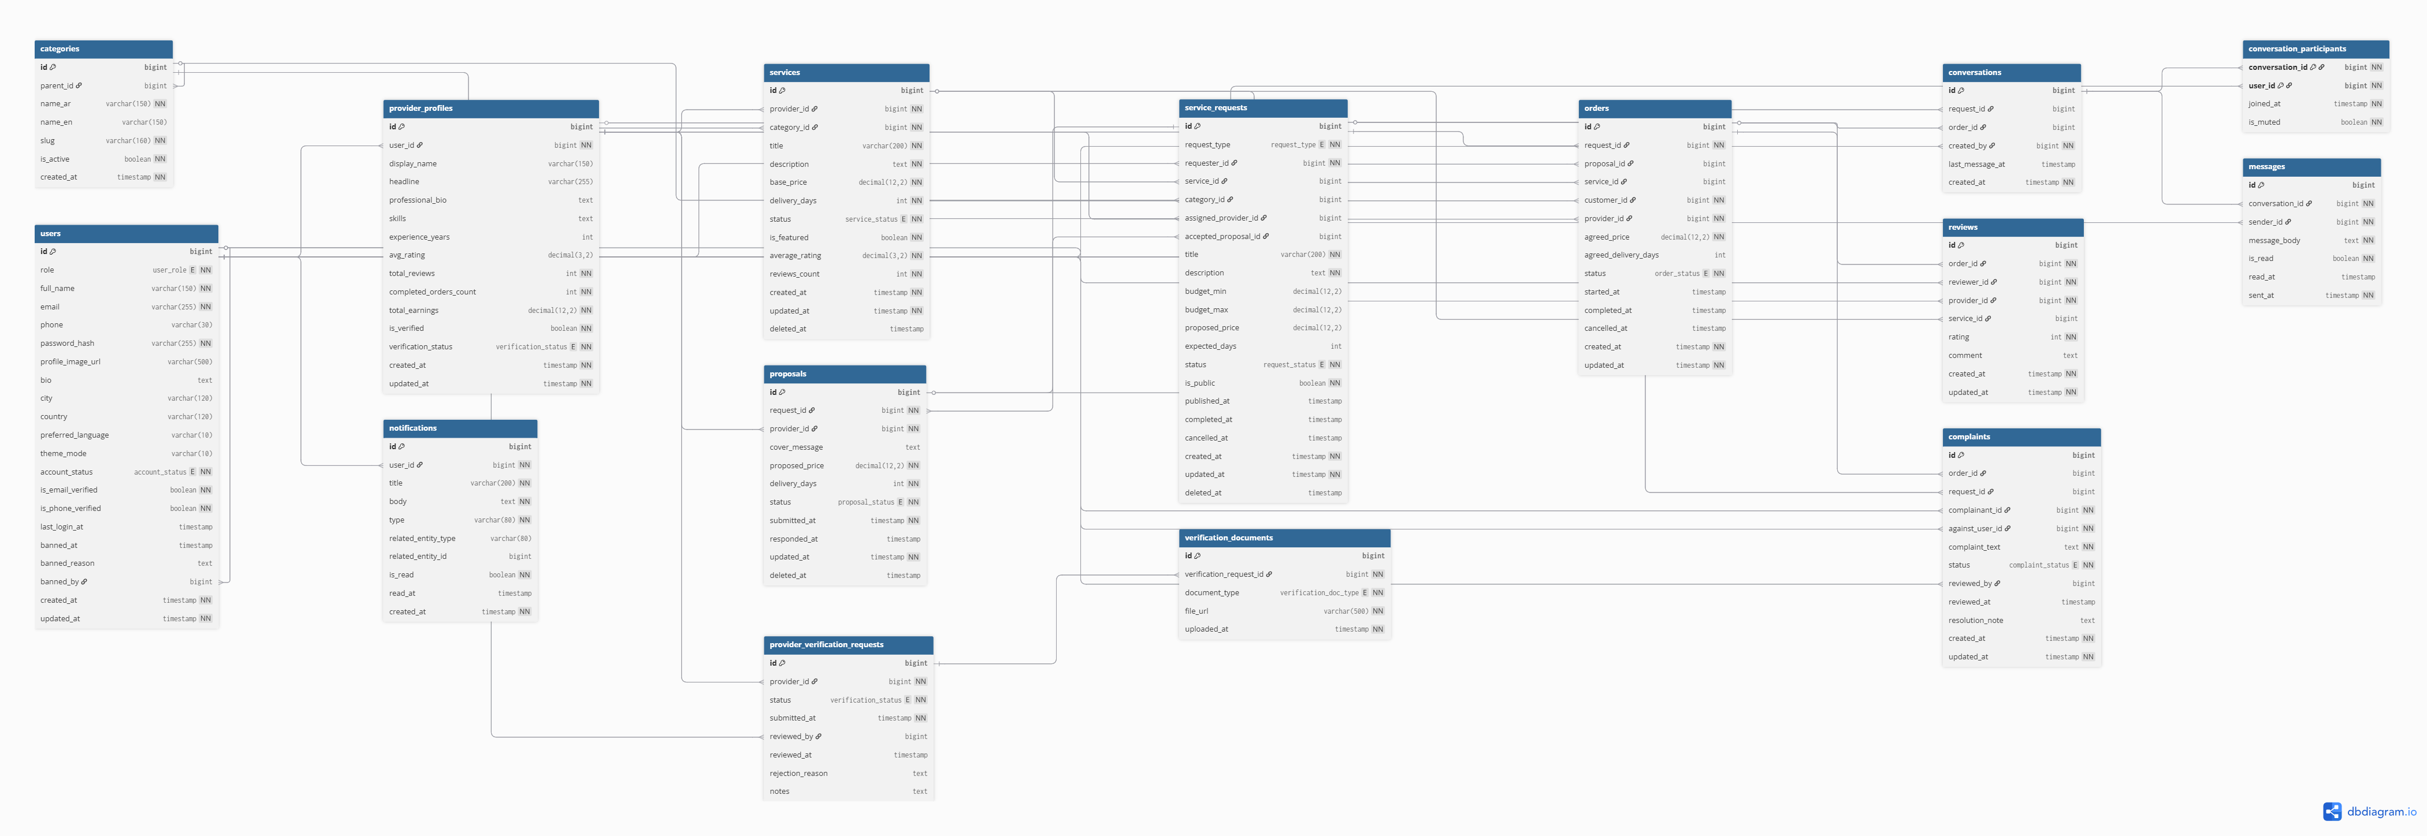
Figure 19 ER Diagram of Syrian Services Hub

5.2.2 Relational Schema
The relational schema translates the conceptual entity model into database tables with identifiable keys and structured attributes. Table 5.2 summarizes the main tables required to support the platform logic.
table 21 Core Relational Schema of Syrian Services Hub
Table Name | Primary Key | Selected Attributes | Purpose
User | user_id | full_name,email, password_hash, role, phone, is_active | Stores platform accounts for visitors after registration, users, providers, and administrators.
ProviderProfile | provider_profile_id | user_id, bio, location, skills, verification_status | Stores professional information related to a service provider.
Category | category_id | name, description | Organizes services into searchable categories.
Service | service_id | provider_profile_id, category_id, title, description, price, delivery_time, status | Stores ready-made services published by providers.
ServiceRequest | request_id | user_id, category_id, title, problem_description, budget, status, created_at | Stores open service-demand advertisements posted by users.
Offer | offer_id | request_id, provider_profile_id, offer_price, delivery_time, proposal_text, status | Stores provider offers submitted in response to service requests.
Conversation | conversation_id | user_id, provider_profile_id, request_id, created_at | Represents a communication channel between the involved parties.
Message | message_id | conversation_id, sender_user_id, body, sent_at, read_status | Stores messages exchanged within a conversation.
Rating | rating_id | service_id, rater_user_id, provider_profile_id, score, feedback, created_at | Stores ratings and feedback after service completion.
Complaint | complaint_id | submitted_by, target_user_id, reason, details, status, created_at | Stores platform complaints and moderation records.
VerificationRequest | verification_id | provider_profile_id, submitted_at, status, reviewed_by, reviewed_at | Stores provider verification submissions and review outcomes.
KnowledgeSource | knowledge_source_id | provider_id, source_type, title, visibility, status, checksum_sha256, created_at, updated_a | Stores provider-owned customer-facing sources and their ingestion state.
KnowledgeChunk | knowledge_chunk_id | document_id, source_id, provider_id, chunk_index, chunk_text, embedding, token_count, visibility, metadata, is_active | Stores searchable evidence segments and vector embeddings used by Ask Assistant.
AssistantSession | assistant_session_id | customer_id, provider_id, order_id, service_id, status, created_at, updated_at | Groups the customer conversation within a provider-specific context.
AssistantTurn | assistant_turn_id | session_id, customer_id, provider_id, question, answer, answer_status, model, input_tokens, output_tokens, latency_ms, created_at | Stores customer questions and assistant answers in chronological order.
AssistantCitation | assistant_citation_id | turn_id, chunk_id, source_id, provider_id, quote, relevance_score, rank, created_a | Links a generated answer to the exact supporting evidence displayed to the user.
In addition to the core tables above, the final implementation may also include supporting tables such as Notification, Attachment, or AuditLog depending on the chosen level of administrative control and traceability.

5.2.3 Constraints and Data Integrity Rules
To preserve consistency and prevent invalid platform states, the relational schema uses primary keys, foreign keys, uniqueness rules, and selected validation constraints. Table 5.3 summarizes representative constraints applied to major entities.
table 22 Main Database Constraints
Table | Constraint Type | Rule | Purpose
User | UNIQUE | email must be unique | Prevents duplicate accounts with the same email.
User | CHECK | role IN (visitor, user, provider, admin) | Restricts the role to valid system roles.
ProviderProfile | FOREIGN KEY | user_id references User(user_id) | Ensures every provider profile belongs to a valid user account.
Service | FOREIGN KEY | provider_profile_id references ProviderProfile(provider_profile_id) | Prevents orphan service records.
Service | CHECK | price >= 0 and delivery_time > 0 | Prevents invalid service values.
ServiceRequest | FOREIGN KEY | user_id references User(user_id) | Links each request to its owner.
Offer | FOREIGN KEY | request_id references ServiceRequest(request_id) | Ensures every offer belongs to a valid request.
Message | FOREIGN KEY | conversation_id references Conversation(conversation_id) | Preserves message-conversation integrity.
VerificationRequest | CHECK | status IN (pending, approved, rejected, revoked) | Supports both granting and revoking verification status.
KnowledgeSource | OWNERSHIP / STATUS | provider_id must match the selected provider; only active customer-visible sources may be retrieved | Prevents cross-provider and inactive-source leakage.
KnowledgeChunk | VECTOR / FK | embedding is stored with a valid source reference and chunk order | Supports similarity retrieval while preserving traceability to the source.
AssistantSession | OWNERSHIP | customer_id and provider_id define the authorized conversation scope | Prevents a session from searching unrelated providers.
AssistantCitation | FK / INTEGRITY | each citation must reference the assistant turn and a retrieved chunk from an authorized source | Ensures every displayed citation can be traced to evidence.

5.3 External API Design
Syrian Services Hub is designed as a web platform in which the frontend interacts with the backend through REST-oriented endpoints. These endpoints allow the client side to retrieve services, submit requests, manage offers, exchange messages, and perform trust-related operations in a structured and predictable way. The API layer also allows the recommendation feature to be requested from the user interface in a standardized form.
Table 5.4 presents representative endpoints used to support the main platform workflows. The final implementation may contain additional endpoints depending on modular refinement and administrative needs.
table 23 Representative API Endpoints
Method | Endpoint | Main Function | Role | Response Type
POST | /api/auth/register | Register account | User / Provider | JSON
POST | /api/auth/login | User login | All registered roles | JSON
GET | /api/services | Browse services | Visitor / User | JSON list
POST | /api/services | Create service | Provider | JSON
POST | /api/requests | Create service request | User | JSON
POST | /api/offers | Submit offer | Provider | JSON
GET | /api/conversations/{id}/messages | Get messages | Authorized parties | JSON list
POST | /api/recommendations | Get suggested solutions and provider | User | JSON
POST | /api/verification-requests | Submit verification request | Provider | JSON
PATCH | /api/admin/providers/{id}/revoke-verification | Revoke verification | Admin | JSON
POST | /api/v1/customer-assistant/questions/ | Ask a provider-specific question and receive a grounded cited answer | Authenticated User | JSON
GET | /api/v1/customer-assistant/sessions/{id}/turns/ | Retrieve authorized Ask Assistant conversation history | Authenticated User | JSON
POST | /api/v1/knowledge/sources/ | Upload a provider-owned customer-facing knowledge source | Provider | Multipart/form-data
POST | /api/v1/knowledge/sources/{id}/reindex/ | Reprocess and re-embed an owned knowledge source | Provider / Admin | JSON

5.4 Security and Access Design
Security in Syrian Services Hub is based on authentication, role-based access control, protected workflows, and administrative oversight. Sensitive operations are restricted according to user roles, while trust-related features such as complaints and verification are managed through controlled processes.
Ask Assistant applies additional safeguards through permission-first retrieval, source visibility checks, citation validation, file validation, rate limiting, audit metadata, and insufficient-evidence handling. Retrieved content is treated as untrusted data to reduce prompt-injection, information leakage, and unsupported responses.

5.4.1 Authentication and Authorization
Registered operations require authenticated access, while permissions are assigned according to the user, provider, or administrator role. Providers can publish services, users can submit service requests, and administrators manage verification and other privileged actions.

5.4.2 Verification and Revocation Control
Provider verification is an administrative process in which submitted evidence is reviewed and either approved or rejected. Administrators may also revoke verification when necessary, ensuring that trust status remains controlled and valid over time

Section Four: Implementation and Testing

Chapter Six: Implementation Environment and Tools
This chapter documents the practical environment used to build Syrian Services Hub and explains the main tools, frameworks, libraries, and execution settings that supported the implementation process. It describes the software stack used for frontend and backend development, the database platform, the testing utilities, dependency management, and the source-control practices applied during development. The chapter also clarifies the relationship between the selected technologies and the system architecture, especially in supporting the client-server and three-tier design adopted by the project.

6.1 Software Tools and Libraries Used
The implementation of Syrian Services Hub relied on a modern web-development stack supported by practical development and testing tools. The selected tools were chosen to match the requirements of a role-based service marketplace platform with structured workflows, database persistence, API communication, and recommendation-oriented processing. The toolset combines frontend development, backend implementation, database management, source control, and API inspection in a way that supports maintainability and modular growth.
table 24 Main software tools and libraries used in the implementation environment
Tool / Library | Role in the Project | Usage Context
Visual Studio Code | Primary development environment | Used for editing source files, project navigation, debugging, and managing the implementation workflow.
React | Frontend user interface library | Used to build the client-side pages, reusable components, dashboards, and interaction flows.
TypeScript | Frontend logic and interactivity | Used to implement component behavior, form interaction, API calls, and client-side state handling.
Django | Backend web framework | Used to implement business logic, role-based workflows, request handling, recommendation processing, and server-side validation.
PostgreSQL | Database management system | Used to store users, provider profiles, services, requests, offers, messages, verification records, and other persistent data.
Postman | API testing and inspection tool | Used to test endpoints, verify request-response behavior, and inspect backend API functionality.
Git / GitHub | Source control and revision tracking | Used to manage versions of the codebase and maintain development history.
OpenAI Python SDK | Embedding and answer-generation integration | Used by the RAG services to create vector embeddings and generate grounded answers from retrieved evidence.
pypdf, python-docx, openpyxl, tiktoken | Document extraction and token-aware chunking | Supports ingestion of approved provider files and preparation of searchable knowledge chunks.

6.2 Development Environment and Project Structure
Syrian Services Hub follows a structured development environment based on the adopted three-tier architecture, separating the frontend, backend, and database layers. This organization improves modularity and keeps interface components, business logic, and persistent data clearly separated.
The frontend and backend operate as coordinated application layers, while the database manages persistent records. This structure supports incremental development and testing of services, requests, offers, messaging, trust-related features, and recommendation functionality while preserving clear architectural boundaries.
table 25 High-level implementation environment structure
Project Layer | Representative Elements | Purpose
Client Layer | React pages, components, forms, dashboards | Provides the user-facing interface for visitors, users, providers, and administrators.
Application Layer | Django views, serializers, business logic, recommendation processing | Handles validation, workflows, role-based actions, and system behavior.
Data Layer | PostgreSQL tables, relations, stored records | Maintains persistent data and supports retrieval, updates, and structured relationships.

6.3 Programming Languages and Frameworks
The implementation of the platform combined frontend and backend technologies that are widely used in modern web systems. React and TypeScript were used on the client side to support dynamic interaction, reusable interface components, stronger type safety, and responsive user flows. On the server side, Django provided the backend framework responsible for routing, validation, workflow handling, recommendation-related processing, and data interaction. This combination was appropriate for a marketplace platform that requires clear separation between user interaction and backend business logic while still maintaining practical development efficiency.
table 26 Programming languages and frameworks used by the project
Technology | Type | Contribution to the System
TypeScript | Programming language | Implements client-side interactivity, request handling, and frontend behavior.
React | Frontend framework/library | Builds dynamic user interfaces and reusable visual components.
Python | Programming language | Supports backend implementation through the Django framework.
Django | Backend framework | Implements APIs, workflow logic, data validation, and recommendation-related processing.
SQL | Database query language | Supports data definition and data manipulation through the PostgreSQL backend.
OpenAI API | AI service integration | Provides embedding generation and evidence-constrained response generation for Ask Assistant.

6.4 Database Server and Operating System
Syrian Services Hub uses PostgreSQL as its primary database server due to its reliability, relational data support, and compatibility with modern backend frameworks. It manages interconnected entities such as users, services, requests, offers, messages, complaints, verification records, and recommendation-related data.
Development is carried out in a standard local operating-system environment capable of running and integrating the frontend, backend, and database components without requiring specialized infrastructure during the development stage.
table 27 Database and execution environment summary
Environment Element | Selected Option | Reason for Selection
Database Server | PostgreSQL | Provides reliable relational persistence, strong integrity support, and suitability for multi-entity platform data.
Execution Model | Local development environment | Supports iterative testing and controlled feature verification during implementation.
System Context | Web-based client-server environment | Matches the platform architecture and the requirement for role-based online interaction.

6.5 Dependencies
The project depends on a set of framework and runtime packages required to support frontend rendering, backend execution, database connectivity, and API communication. In the backend environment, dependencies are managed through Python package installation, while the frontend relies on a TypeScript-based toolchain and package management for component rendering and interface behavior. Dependency tracking is important because it ensures that the platform can be rebuilt consistently and that the implementation environment remains reproducible.
table 28 Main dependency groups used by the project
Dependency Group | Examples | Function
Backend packages | Django and related Python packages | Provide routing, validation, ORM support, and server-side functionality.
Frontend packages | React and TypeScript dependencies | Provide rendering, state management, and component-based interface behavior.
Database connector packages | PostgreSQL integration packages | Enable communication between backend logic and persistent storage.
Testing / utility packages | Request inspection and development utilities | Support API validation, debugging, and controlled implementation checks.
RAG and document-processing packages | openai,,pypdf,,python-docx, openpyxl, | Provide embeddings, grounded answer generation, file extraction,

6.6 Version Control and Source Management Tools
Version control was handled through Git and GitHub in order to preserve the development history of Syrian Services Hub and reduce the risk of losing implementation progress during iterative work. Source control is especially important in a project that evolves across analysis, design, and implementation because code revisions must remain traceable and recoverable. Git-based source management also supports structured modification of frontend and backend modules, incremental refinement of project files, and safer maintenance of the codebase over time.
table 29 Version control and source-management tools
Tool | Purpose | Practical Benefit
Git | Version control | Tracks changes, supports rollback, and preserves implementation history.
GitHub | Repository hosting and collaboration | Stores the codebase remotely and supports organized source management.

6.7 Continuous Integration and Deployment Tools
At the current project stage, Syrian Services Hub did not rely on a dedicated automated continuous-integration or deployment pipeline. The implementation process focused on controlled local development, iterative testing, and direct verification of frontend-backend interaction. This is acceptable within the scope of an academic graduation project because the primary objective at this stage is to build, validate, and document the core system rather than establish a production-grade deployment workflow. Nevertheless, the project structure remains suitable for future extension toward CI/CD integration if the system is later developed into a larger deployable platform.
table 30 CI/CD status within the current project scope
Aspect | Current Status | Future Possibility
Continuous Integration | Not automated in the current academic scope | Can be extended later through automated testing and build pipelines.
Continuous Deployment | Not applied at the current project stage | Can be introduced when the system moves toward hosted production deployment.

6.8 Testing Environment
Syrian Services Hub was tested primarily in a local development environment integrating the React frontend, Django backend, and PostgreSQL database. Postman was also used to validate API behavior independently when required.
Testing focused on role-based access, service workflows, request and offer handling, messaging, verification, recommendation responses, and data persistence. This setup supported rapid debugging, repeated validation, and efficient incremental testing throughout development.
table 31 Testing environment elements used during implementation
Testing Element | Environment / Tool | Purpose
Frontend validation | Local browser execution | Checks interface behavior, navigation, forms, and dashboard interaction.
Backend validation | Local Django execution | Checks logic processing, endpoint behavior, and workflow correctness.
API testing | Postman | Validates request-response structures and endpoint correctness.
Database validation | PostgreSQL local execution | Checks data persistence, relations, and stored results after operations.
RAG validation | Django/DRF test client, pytest, PostgreSQL, mocked or controlled OpenAI responses | Checks ingestion, permission filtering, retrieval relevance, citations, insufficient-evidence behavior, and API contracts.

Overall, the implementation environment of Syrian Services Hub reflects a practical and coherent web-development setup that is consistent with the system architecture, the project requirements, and the academic scope of the graduation project.

Chapter Seven: Software Implementation
This chapter presents the practical implementation of Syrian Services Hub and explains how the designed architecture was translated into an operational software structure. It covers the project folder organization, the implementation of the main functional modules, the API layer, the data-access responsibilities, the business-logic layer, the user interface, and the implementation status of the intelligent recommendation-oriented functionality.

7.1 Project Structure and File Organization
The implementation of Syrian Services Hub follows a repository structure that separates the frontend, backend, documentation, and tracking assets of the project. According to the repository definition, the platform is built as a full-stack service marketplace with a React and TypeScript frontend and a Django plus Django REST Framework backend. The codebase is organized to support incremental development, clear domain separation, and maintainable delivery artifacts.
table 32 High-level repository structure of Syrian Services Hub
Directory | Purpose
frontend/ | Contains the client-side application, user interface pages, routing, state management, and API integration logic.
backend/ | Contains the Django and DRF server-side code, domain modules, authentication, business rules, and API endpoints.
docs/ | Contains architecture, system, API, security, and delivery documentation.
tracking/ | Contains work-management records, decisions, risks, changelog notes, and open implementation questions.
.vscode/ and root files | Contain local editor configuration and repository-level setup files.

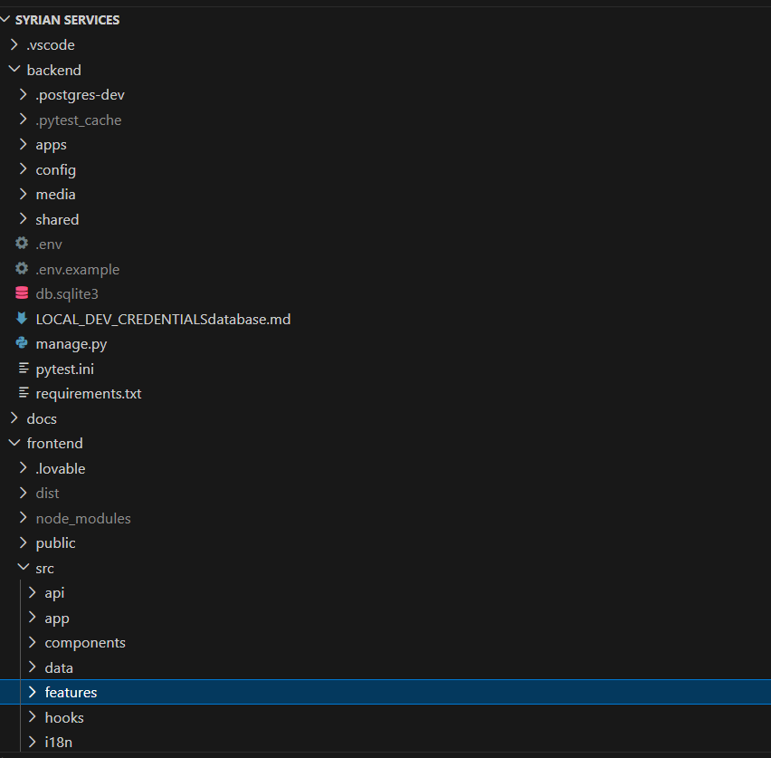
Figure 20 Placeholder for the project structure

7.2 Implementation of Major Functional Modules
The backend implementation is organized around a set of domain-oriented modules that collectively realize the service marketplace workflows of the platform. The repository identifies the core domains as accounts, providers, services, orders, bids, chat, complaints, reviews, notifications, and admin_panel. In practical terms, these modules implement the functional scope discussed in the requirements chapter, including user accounts, provider profiles, service publishing, service-demand workflows, offer submission, communication, trust-related actions, and administrative supervision. This modular organization improves maintainability by separating concerns while keeping all business capabilities within a unified backend project.
table 33 Main implementation modules and their responsibilities
Module | Main Responsibility
accounts | User registration, login, session handling, profile basics, and role-aware account operations.
providers | Provider-specific profiles, provider status, and provider-related marketplace data.
services | Service creation, update, listing, and marketplace presentation logic.
orders | Customer-side service requests and order progression workflows.
bids | Offer and bid submission, review, and response handling between providers and users.
chat | Message exchange and conversation support between marketplace participants.
complaints and reviews | Trust-building functions such as complaints, dispute-related actions, and user feedback records.
recommendations | Recommendation-oriented processing for customer problems, suggested solutions, and provider matching
reviews | Ratings, reviews, and feedback related to completed marketplace interactions
notifications and admin_panel | System notifications, administrative monitoring, moderation-related supervision, and control operations.
knowledge | Provider-owned knowledge sources, documents, chunks, ingestion jobs, embeddings, visibility, and retrieval.
customer_assistant | Authenticated provider-specific questions, conversation sessions, grounded answers, insufficient-evidence handling, and citations.

7.3 API Implementation
Add Service Listing API
This section presents a simple implemented API from the Syrian Services Hub project. The selected API allows an authenticated service provider to create a new service listing on the platform.
API Name | Create Service Listing API
HTTP Method | POST
Endpoint | /api/v1/services/me/
Access | Authenticated provider only
Purpose | Create and store a new service listing for the logged-in provider

Request Processing Flow
1 | The provider submits the service information through a POST request.
2 | The API validates the submitted fields.
3 | The service layer confirms that the logged-in user is a provider.
4 | The new service record is saved and returned in the response.

1. Main API Route
File Location: backend/config/urls.py
PYTHON | ROUTING
path("api/v1/services/", include("apps.services.api.urls")),

Explanation: This line registers the services module in the main backend routing file. Therefore, every service-related endpoint begins with the /api/v1/services/ path prefix.

2. Service Creation Endpoint
File Location: backend/apps/services/api/urls.py
PYTHON | ENDPOINT
path("me/", MyServicesView.as_view(), name="services-me"),

Explanation: This route connects the /me/ path to MyServicesView. Combined with the main prefix, the final service creation endpoint is POST /api/v1/services/me/.3. Request Data Validation
File Location: backend/apps/services/api/serializers.py
PYTHON | SELECTED VALIDATION FIELDS
class ServiceCreateUpdateSerializer(serializers.Serializer):
title = serializers.CharField(max_length=255)
description = serializers.CharField()
category = serializers.CharField(max_length=60)
price = serializers.DecimalField(max_digits=10, decimal_places=2)
price_type = serializers.ChoiceField(
choices=["fixed", "hourly", "starting_at"]
)

Explanation: The serializer checks the essential service information before creation. It validates the title, description, category, price, and allowed price type values. Optional fields such as duration and active status are omitted here for brevity.

4. API View Implementation
File Location: backend/apps/services/api/views.py
PYTHON | CREATE REQUEST HANDLER
class MyServicesView(APIView):
permission_classes = [permissions.IsAuthenticated]
def post(self, request):
serializer = ServiceCreateUpdateSerializer(data=request.data)
serializer.is_valid(raise_exception=True)
service = ServiceListingService.create_service(
actor=request.user,
attrs=serializer.validated_data
)
return success_response(
data={"service": ServiceSerializer(service).data},
message="Service created",
status_code=201
)

Explanation: The view accepts a POST request from an authenticated user, validates the request data, calls the service creation logic, and returns the newly created service with HTTP status code 201.

5. Business Rule and Database Creation
File Location: backend/apps/services/services/service_service.py
PYTHON | BUSINESS LOGIC
def create_service(*, actor, attrs):
if actor.role != "provider":
raise PermissionDeniedDomain("Only providers can create services.")
provider = ProviderService.get_or_create_for_user(actor)
normalized_attrs = dict(attrs)
normalized_attrs["category"] = provider.category
return ServiceRepository.create(provider=provider, **normalized_attrs)

Explanation: The business layer verifies that only providers can add services, creates the record through the repository layer, and uses the category stored in the provider profile before saving.

6. Example Request Body
JSON | REQUEST BODY
{
"title": "Home Electrical Repair",
"category": "Electrical",
"price": "50000.00",
"price_type": "fixed"
}

Explanation: The provider submits the main service details in JSON format.

7. Example Response Body
JSON | SUCCESS RESPONSE
{
"success": true,
"message": "Service created",
"data": {
"service": {
"id": 1,
"title": "Home Electrical Repair"
}
}
}

Explanation: The backend confirms successful creation and returns the created service data.

7.4 Implementation of the Data-Access Layer
The backend follows a layered organization in which persistence concerns are kept separate from request handling and higher-level business rules. The repository guidance states that persistence logic should remain in repositories and selectors, while API transport logic should remain in the presentation layer and business rules should remain in the service layer. This implementation choice supports cleaner domain boundaries and reduces the risk of mixing data-access code with workflow-specific logic. In practice, the data-access layer is responsible for retrieving, storing, and updating marketplace records such as users, services, orders, bids, chats, complaints, and reviews.
table 35 Data-access responsibilities in the implementation
Layer Element | Implementation Responsibility
Models and persistence structures | Represent stored entities and their relationships inside the PostgreSQL-backed backend system.
Repositories / selectors | Retrieve, filter, aggregate, and persist records required by the marketplace workflows.
Data transactions | Support reliable creation and update operations for service, order, bid, and interaction records.

7.5 Implementation of the Business-Logic Layer
The business-logic layer is a central part of the implementation because it coordinates platform rules independently from both the user interface and the persistence mechanisms. The repository standards explicitly state that business rules should be kept in the backend service layer. This means that core workflow decisions, permission checks, ownership validation, marketplace state transitions, and trust-related rules are handled through server-side services rather than scattered across controllers or UI code. Such a design is especially important for Syrian Services Hub because the platform supports multiple roles, service requests, bids, reviews, complaints, and administrative actions that must remain consistent across the system.
table 36 Representative business-logic responsibilities
Business Area | Examples of Implemented Logic
Authentication and access control | Role-based authorization, ownership checks, and protected access to domain operations.
Marketplace workflow control | Validation of service, order, and bid actions according to platform rules and user roles.
Trust and supervision | Complaint-related handling, review constraints, and administrative control over monitored processes.
Verification governance | Verification status review and administrative control over provider verification states, including revocation when required.
Ask Assistant orchestration | Validate the selected provider and user scope, rewrite or normalize the question when needed, retrieve evidence, generate a grounded response, reject unsupported answers, persist turns, and create citations.

7.6 User Interface Implementation
The frontend implementation is built with React and TypeScript and is organized as the client-facing layer of the platform. The repository describes the frontend as an existing React application that was incrementally stabilized and refactored, which means that the implementation process focused on preserving useful interface value while improving structure and backend integration. The user interface supports the main marketplace roles and workflows through pages and interactive components for service browsing, authentication, profile interaction, service requests, bids, and role-aware dashboards. In addition, the frontend was integrated with backend contracts through API adapters, helping the client application operate against the implemented server-side modules rather than mock-only flows.

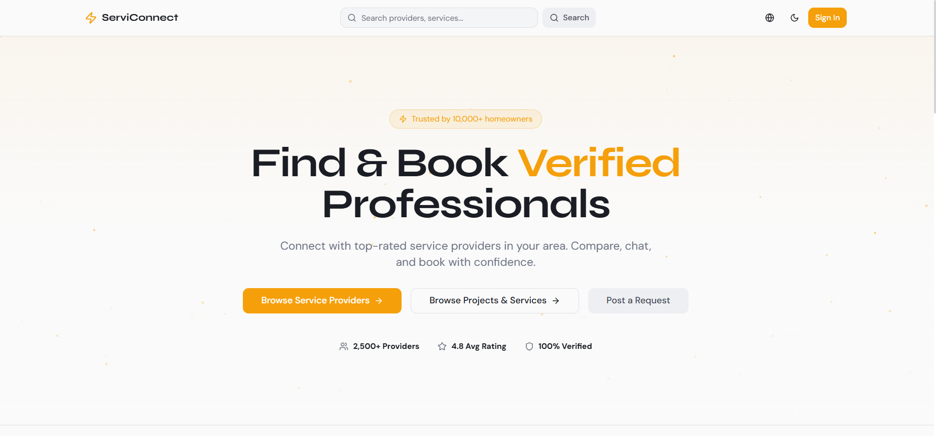
Figure 21 Placeholder for a main marketplace interface screenshot.

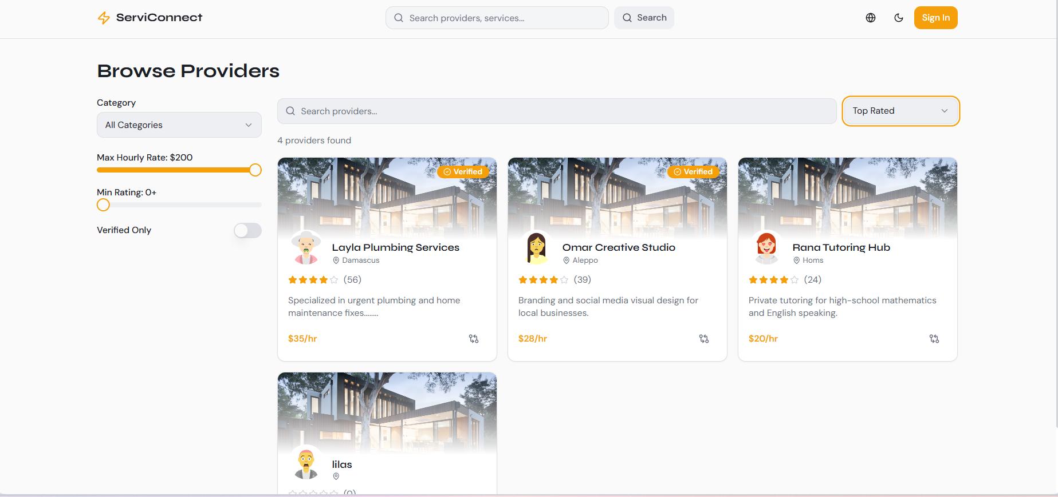
Figure 22 service-request interface screenshot

7.7 Implementation of the Intelligent Recommendation-Oriented Functionality
Syrian Services Hub includes an intelligent recommendation-oriented feature designed to assist users in identifying relevant services and suitable providers based on their submitted needs.
The current implementation primarily focuses on the core marketplace modules, authentication, frontend-backend integration, and workflow reliability. The recommendation capability is therefore implemented as an incremental extension aligned with the existing architecture and project requirements.
Its integration within the business logic layer allows the intelligent functionality to evolve independently while maintaining compatibility with the platform’s core services, data structures, and operational workflows.
table 37 Implementation positioning of the recommendation-oriented feature
Aspect | Implementation Interpretation
Input | A user-provided problem description or expressed service need.
Expected output | Suggested service direction and a suitable provider recommendation.
Architectural position | Implemented as an extensible logic component connected to marketplace data and workflow context.
Current implementation emphasis | Core marketplace modules and integration are primary; recommendation support is framed as the intelligent extension of the platform.

7.8 Implementation of Ask Assistant (RAG)
Ask Assistant is implemented independently from AI Recommendation through two backend domains: knowledge and customer_assistant. The knowledge domain manages provider-owned sources, content extraction, chunking, embeddings, and retrieval, while customer_assistant handles sessions, questions, answers, and citations.
The main endpoint, POST /api/v1/customer-assistant/questions/, authenticates users, validates provider context, processes questions, and returns grounded answers with citations and session data. Providers can also upload, archive, and reindex their authorized knowledge sources.
During ingestion, documents are validated, extracted, divided into overlapping chunks, and converted into vector embeddings.

Chapter Eight: Testing and Evaluation
This chapter evaluates the functionality, reliability, usability, and security of Syrian Services Hub. Testing focuses on the main marketplace workflows, role-based access, communication, administrative operations, and intelligent features to confirm that system requirements are implemented as observable and testable behavior.

8.1 Test Plan
The test plan defines the testing scope, objectives, environment, responsibilities, and acceptance criteria. It emphasizes scenario-based testing of key workflows, including browsing, account operations, service management, requests, offers, messaging, ratings, complaints, verification, and recommendation functionality.
Ask Assistant is tested separately from AI Recommendation, focusing on provider authorization, source visibility, ingestion status, retrieval relevance, citation accuracy, answer grounding, conversation ownership, and correct handling of insufficient evidence.
table 38 Test plan overview
Item | Description
Testing Objective | Verify that the main system workflows operate correctly and satisfy the documented functional and non-functional requirements.
Testing Scope | Accounts, services, service requests, offers, messaging, reviews, complaints, verification, dashboards, and recommendation functionality.
Testing Approach | Manual scenario-based testing supported by API validation for backend endpoints and workflow behavior.
Testing Environment | Local development environment using the implemented frontend, backend, database, and API testing tools.
Testing Tools | Browser-based testing, Postman for API checks, development logs, and database inspection when needed.
Acceptance Criteria | A workflow is accepted when it produces the expected result, prevents invalid behavior, respects permissions, and keeps stored data consistent.
RAG Testing Scope | Knowledge-source ingestion, provider ownership, active-source filtering, vector retrieval, Ask Assistant API, citations, session history, and insufficient-evidence handling.

8.2 Types of Testing
Several testing types are relevant to Syrian Services Hub because the platform combines user-facing interaction, backend services, database operations, and access-control rules. The testing strategy therefore includes functional testing for feature correctness, integration testing for communication between frontend and backend layers, system testing for full workflow validation, acceptance testing for user-oriented scenarios, security testing for permissions and protected operations, performance-oriented checks for responsiveness, and usability review for interface clarity.
table 39 Types of testing applied to Syrian Services Hub
Testing Type | Purpose | Examples in the Project
Functional Testing | Validate individual functions against expected behavior. | Login, service creation, request posting, offer submission, complaint creation.
Integration Testing | Verify interaction between frontend, API layer, backend logic, and database. | Submitting a request from the interface and storing it correctly in the database.
System Testing | Validate complete end-to-end workflows. | User posts a request; provider submits an offer; user accepts or rejects the offer.
Acceptance Testing | Check that key workflows satisfy stakeholder needs. | User can find a relevant service or provider using browsing or recommendation.
Security Testing | Verify role-based access and protected operations. | Only Admin can manage complaints or revoke provider verification.
Performance Checks | Observe responsiveness during common operations. | Browsing services, filtering, opening dashboards, and submitting forms.
Usability Review | Evaluate clarity, navigation, and user experience. | Checking whether forms, statuses, and actions are understandable.
RAG Grounding and Permission Testing | Verify that answers use only authorized active evidence and that every supported answer is traceable. | A provider-specific question returns a cited answer; private, archived, unrelated, or weak evidence is excluded and produces a safe response.

8.3 Test Diagrams
Test diagrams are used to summarize the testing workflow and show how major scenarios move from requirement selection to execution and result recording. They help clarify the relationship between requirements, test cases, expected results, and final evaluation. Since the actual detailed diagrams are maintained separately as project figures, this section reserves the required locations for inserting the final testing diagrams without increasing the working file size.

8.3.1 Test Case Diagram
The test case diagram should represent the main testable workflows of the platform, especially the scenarios that involve multiple actors or critical system behavior. These include service browsing, service request creation, offer submission, provider verification handling, complaint management, and recommendation generation.
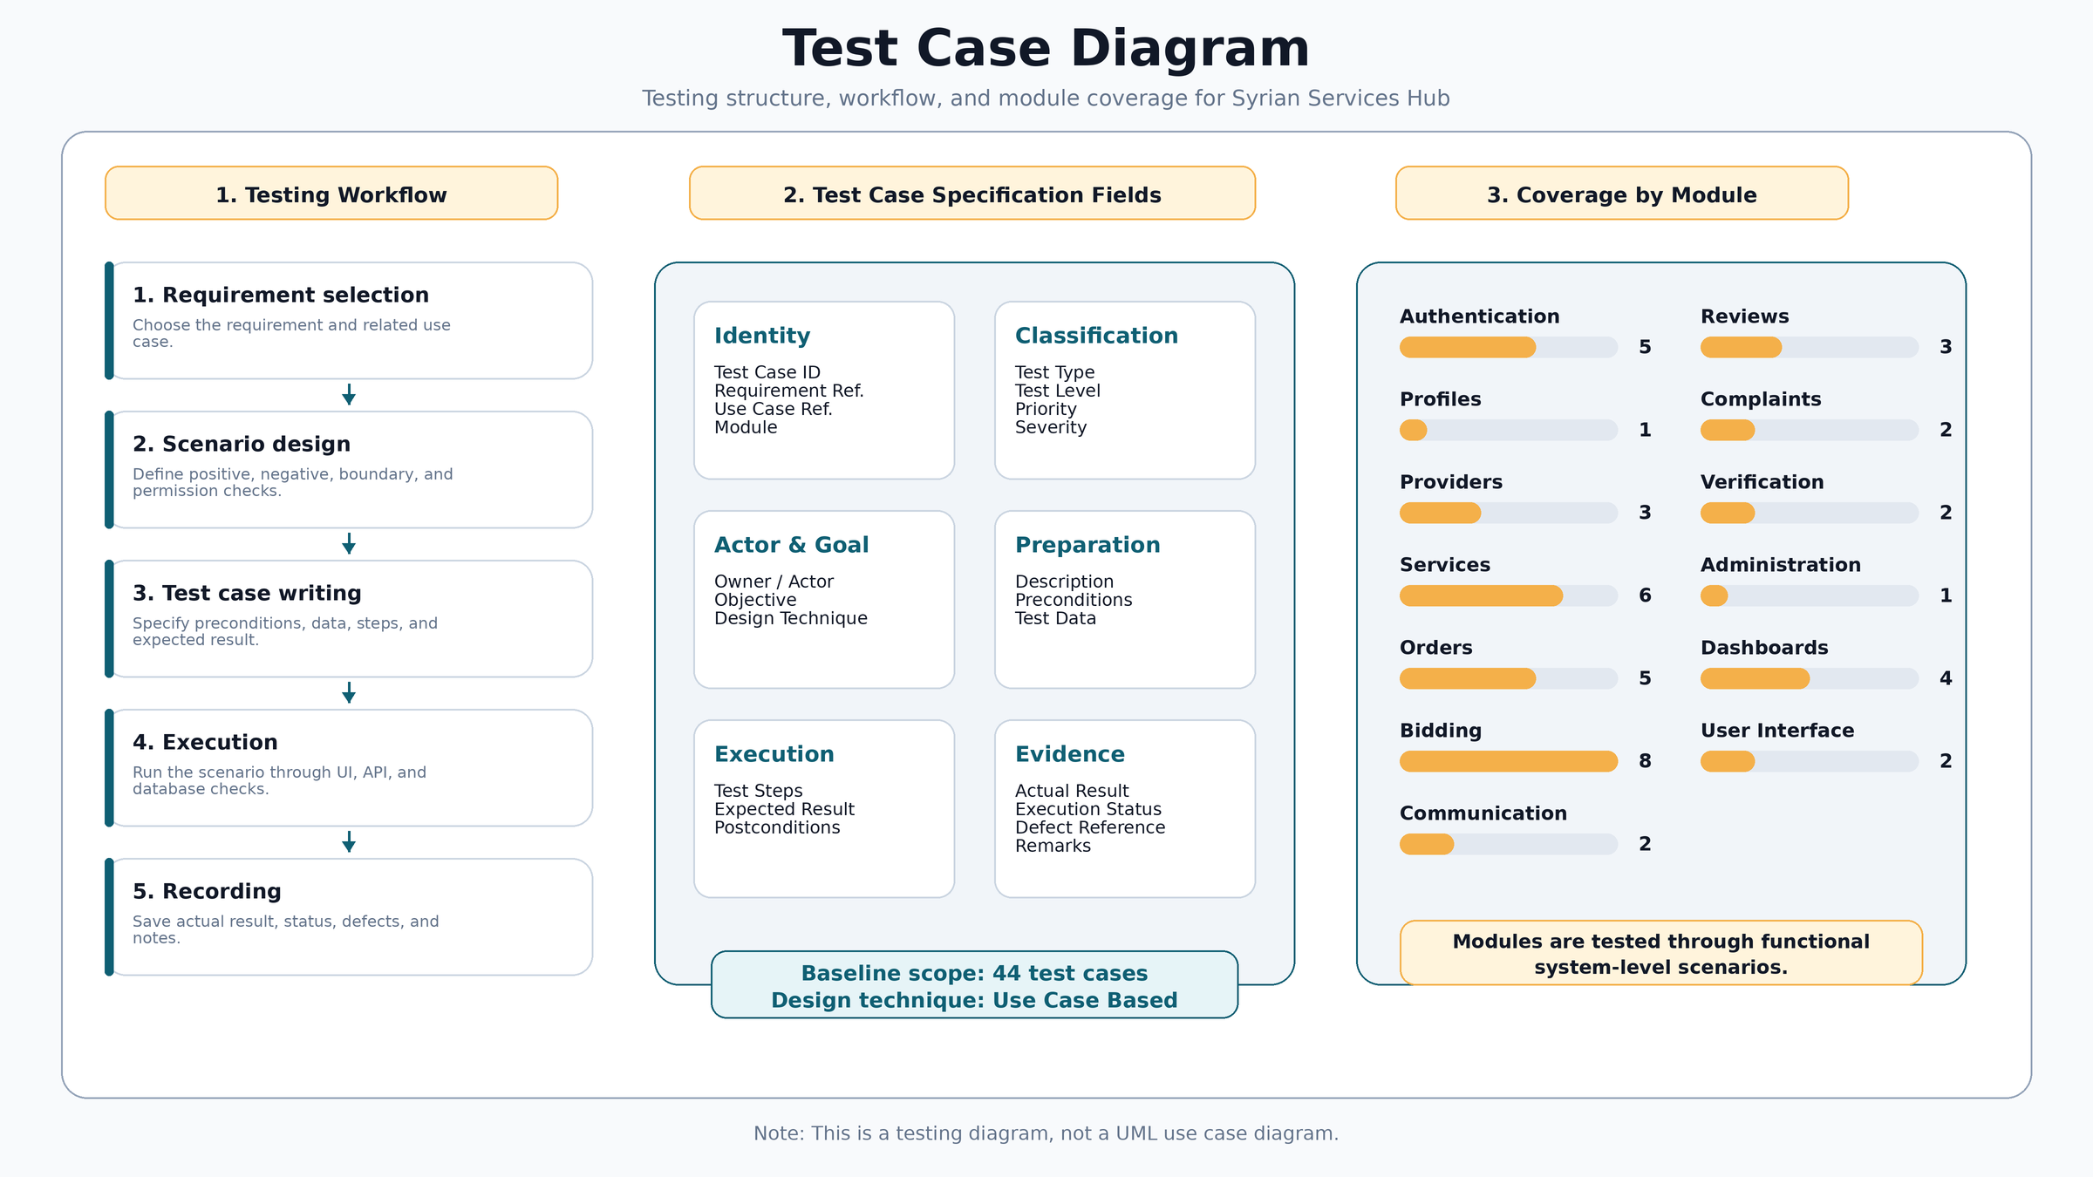

Figure 8.1: Test case diagram for the main testable workflows of Syrian Services Hub.

8.3.2 Test Results Diagram
The test results diagram should summarize the status of executed test cases, such as passed, failed, or pending items. It can be represented as a simple chart after the final execution results are confirmed. This keeps the evaluation section visually clear while preserving the detailed results in the testing tables.
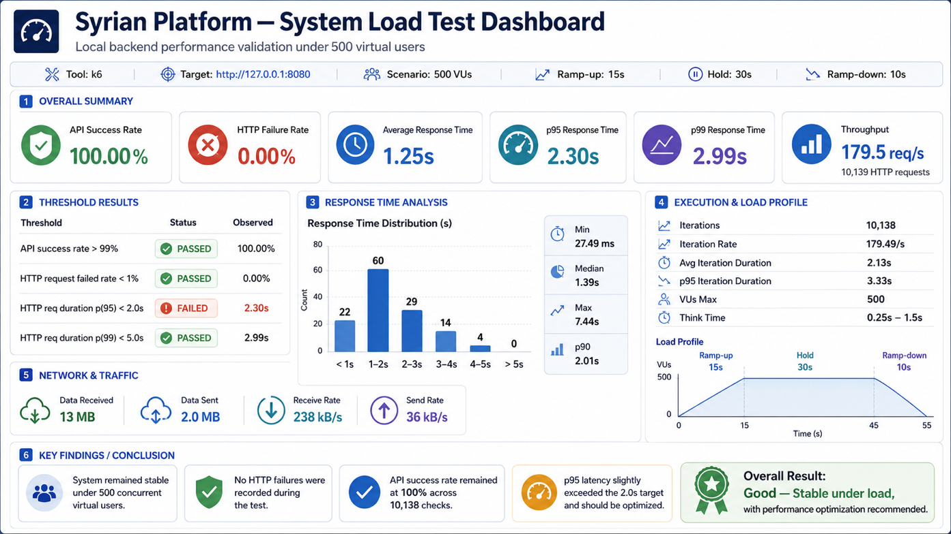

Figure 8.2: Summary diagram of testing results and validation status.

8.4 Test Results and Analysis
The following test cases summarize the main validation scenarios for Syrian Services Hub. The selected cases focus on the core platform behavior and the most important stakeholder workflows. They also include the intelligent recommendation feature and administrative verification control because these parts are essential to the system scope and should be verified clearly. The results are structured around expected outcomes and acceptance status, which makes the testing process traceable to the requirements and use case descriptions defined earlier.

table 40 Main test cases and validation results add services
Test Case ID | TC-SERV-001 | Requirement Ref. | SERV-001
Use Case Ref. | UC-10 | Module | Services
Title | Add Service | Owner / Actor | Provider
Test Type | Functional / Positive | Test Level | System
Priority | High | Severity | High
Risk Level | High | Automation Candidate | Medium
Objective | Verify that the system satisfies the Add Service requirement according to the defined main scenario. | Design Technique | Use Case Based
Description |  | Allows the service provider to add a new service that includes the service name, description, price, and execution duration.
Pre-conditions |  | - The required actor is logged in.  - The Add Service page is available.
Test Data / Input |  | - Service Name: Air Conditioner Maintenance  - Price: 150  - Execution Duration: Two days
Test Steps |  | - Open the screen or section related to the "Add Service" feature.  - Enter or select valid test data when needed.  - Perform the main action related to the feature.  - Review the result displayed to the user or actor.  - Verify that the change is saved or that data is retrieved from the database according to the expected behavior.
Expected Result |  | - A new service record linked to the service provider is created.  - No unexpected error messages or behavior that contradicts the scenario appear.  - The interface or data is updated according to the performed operation.
Post-conditions |  | A new service record linked to the service provider is created.
Exception Notes |  | There are no additional exception notes within this basic case; other scenarios are covered in later test cases.
Actual Result | The test case TC-SERV-001 for "Add Service" was executed successfully, and the actual result matched the expected result with no functional errors. | Execution Status | Pass
Defect Reference | N/A | Executed By | QA Tester
Reviewed By | QA Lead | Date Created | 2026-03-10
Execution Date | 2026-03-10 | Remarks / Notes | These fields were filled as an initial execution sample and can be updated during actual execution.

table 41 Main test cases and validation results submit offer

Test Case ID | TC-SERV-008 | Requirement Ref. | SERV-008
Use Case Ref. | UC-17 | Module | Orders
Title | Submit Offer on Service Request | Owner / Actor | Provider
Test Type | Functional / Positive | Test Level | System
Priority | High | Severity | High
Risk Level | High | Automation Candidate | Medium
Objective | Verify that the system satisfies the Submit Offer on Service Request requirement according to the defined main scenario. | Design Technique | Use Case Based
Description |  | Allows the service provider to respond to the service request sent by the user by submitting an offer that includes the price, duration, or execution details.
Pre-conditions |  | - The required actor is logged in.  - There is an incoming service request with Pending status.
Test Data / Input |  | - Proposed Price: 120  - Proposed Duration: 2 days  - Execution Details: Visit and inspection
Test Steps |  | - Open the screen or section related to the "Submit Offer on Service Request" feature.  - Enter or select valid test data when needed.  - Perform the main action related to the feature.  - Review the result displayed to the user or actor.  - Verify that the change is saved or that data is retrieved from the database according to the expected behavior.
Expected Result |  | - A new offer record linked to the service request is created, and the request status is updated to indicate that it has been answered with an offer.  - No unexpected error messages or behavior that contradicts the scenario appear.  - The interface or data is updated according to the performed operation.  - In the exceptional scenario: the offer data is invalid or the request is no longer in Pending status.
Post-conditions |  | A new offer record linked to the service request is created, and the request status is updated to indicate that it has been answered with an offer.
Exception Notes |  | The offer data is invalid or the request is no longer in Pending status.
Actual Result | The test case TC-SERV-008 for "Submit Offer on Service Request" was executed successfully, and the actual result matched the expected result with no functional errors. | Execution Status | Pass
Defect Reference | N/A | Executed By | QA Tester
Reviewed By | QA Lead | Date Created | 2026-03-10
Execution Date | 2026-03-10 | Remarks / Notes | These fields were filled as an initial execution sample and can be updated during actual execution.

table 42 Main test cases and validation results post new request

Test Case ID | TC-BID-001 | Requirement Ref. | BID-001
Use Case Ref. | UC-21 | Module | Bidding
Title | Post New Request | Owner / Actor | User
Test Type | Functional / Positive | Test Level | System
Priority | High | Severity | High
Risk Level | High | Automation Candidate | Medium
Objective | Verify that the system satisfies the Post New Request requirement according to the defined main scenario. | Design Technique | Use Case Based
Description |  | Allows the user to post a service request with the service description and expected budget.
Pre-conditions |  | - The required actor is logged in.  - The Post New Request page is available.
Test Data / Input |  | - Description: Electrical network installation  - Expected Budget: 500
Test Steps |  | - Open the screen or section related to the "Post New Request" feature.  - Enter or select valid test data when needed.  - Perform the main action related to the feature.  - Review the result displayed to the user or actor.  - Verify that the change is saved or that data is retrieved from the database according to the expected behavior.
Expected Result |  | - A new service request record is created in the database.  - No unexpected error messages or behavior that contradicts the scenario appear.  - The interface or data is updated according to the performed operation.
Post-conditions |  | A new service request record is created in the database.
Exception Notes |  | There are no additional exception notes within this basic case; other scenarios are covered in later test cases.
Actual Result | The test case TC-BID-001 for "Post New Request" was executed successfully, and the actual result matched the expected result with no functional errors. | Execution Status | Pass
Defect Reference | N/A | Executed By | QA Tester
Reviewed By | QA Lead | Date Created | 2026-03-10
Execution Date | 2026-03-10 | Remarks / Notes | These fields were filled as an initial execution sample and can be updated during actual execution.

8.5 Quality Metrics
Quality metrics are used to evaluate whether the platform satisfies the non-functional expectations defined earlier in the requirements chapter. In this project, the most relevant metrics are usability, response behavior, security, reliability, traceability, and recommendation relevance. Since the project is an academic software engineering system, the evaluation focuses on practical indicators that can be checked through manual testing, workflow review, and implementation inspection.
table 45 Quality metrics used in the evaluation
Quality Aspect | Metric / Indicator | Evaluation Method | Target
Usability | Clarity of navigation, forms, and status messages. | Manual walkthrough of key workflows. | Users can complete the main actions without confusion.
Performance | Observed response during common operations. | Browsing, filtering, form submission, and dashboard access. | No blocking delay during normal local testing.
Security | Role-based access and protected administrative actions. | Permission checks and unauthorized-action attempts. | Restricted actions remain accessible only to allowed roles.
Reliability | Consistency of stored records and workflow transitions. | Database and UI state verification after actions. | Created records remain linked to the correct user, request, or provider.
Traceability | Connection between requirements and test cases. | RTM and testing tables. | Each critical requirement has at least one related test case.
Recommendation Relevance | Returned suggestions match the entered problem context. | Manual review of recommendation outputs. | Suggested solutions and providers are meaningfully related to the user problem.
RAG Groundedness | Citation coverage, evidence support, and safe refusal rate. | Review answer-citation pairs and execute unsupported-question scenarios. | Supported factual answers are cited and evidence-based; unsupported answers are not fabricated.

8.6 Usability Testing
Usability testing focuses on whether the main actors can understand and complete the platform workflows in a clear and efficient way. For Syrian Services Hub, usability is especially important because the platform serves different roles with different expectations: visitors need simple browsing, users need clear request and recommendation paths, providers need organized service and offer management, and administrators need understandable control workflows. The usability review therefore focused on the clarity of page structure, the visibility of actions, the simplicity of forms, and the understandability of status changes.
table 46 Usability review observations
Area | Observation | Improvement Direction
Service browsing | Users should be able to reach services quickly through clear navigation. | Keep categories, cards, and filters visible and simple.
Request posting | The service-demand form should be direct and easy to complete. | Use concise labels, validation messages, and clear submission feedback.
Offer management | Offer status should be understandable for both user and provider. | Use consistent labels such as pending, accepted, rejected, or completed.
Recommendation page | The user should understand what to enter and what the system will return. | Explain that the system returns suggested solutions and a suitable provider.
Administrative actions | Sensitive actions such as verification review and revocation should be explicit. | Use confirmation messages and clear status indicators.
Ask Assistant panel | The user should understand the selected provider context, the evidence-based nature of the answer, and the meaning of citations or insufficient evidence. | Show provider context, question input, answer, source links/excerpts, loading state, and a clear insufficient-evidence message.

The usability evaluation shows that the platform should remain simple and role-oriented. The most important usability requirement is to prevent users from feeling that the system has too many unrelated options. Instead, each actor should see clear actions related to their role. This supports the broader objective of Syrian Services Hub as a structured and accessible service marketplace.

8.7 Evaluation Summary
The testing and evaluation process demonstrates that Syrian Services Hub can be validated through a structured set of functional, integration, security, usability, and quality-oriented checks. The selected test cases cover the most important workflows, including browsing, account access, service management, service requests, offers, messaging, complaints, verification control, and recommendation support. The evaluation confirms that the system behavior can be tested against clear criteria and that the major requirements are connected to practical validation scenarios. The remaining visual testing artifacts, such as the test case diagram and results diagram, can be inserted later without changing the structure or content of this chapter.

Section Five: Results and Recommendations

Chapter Nine: Results and Analysis
This chapter presents the main results achieved by Syrian Services Hub and analyzes how the developed system responds to the project objectives. It summarizes the practical output of the platform, compares the proposed solution with existing service marketplace platforms, evaluates the degree to which the project goals were achieved, and discusses the main strengths, limitations, and performance indicators of the system.

9.1 System Results
The implementation of Syrian Services Hub resulted in a structured digital marketplace supporting visitors, users, service providers, and administrators through role-based access. Core functions include service browsing, service requests, offer management, messaging, provider profiles, complaints, verification, and administrative monitoring.
The platform also incorporates an intelligent recommendation feature that analyzes a user's problem description to suggest relevant solutions and suitable service providers, helping users translate their needs into more informed service decisions.
In addition, Ask Assistant provides authenticated, provider-specific question answering using approved knowledge sources. Grounded answers are stored with citations, giving users transparent and traceable information about providers and services.
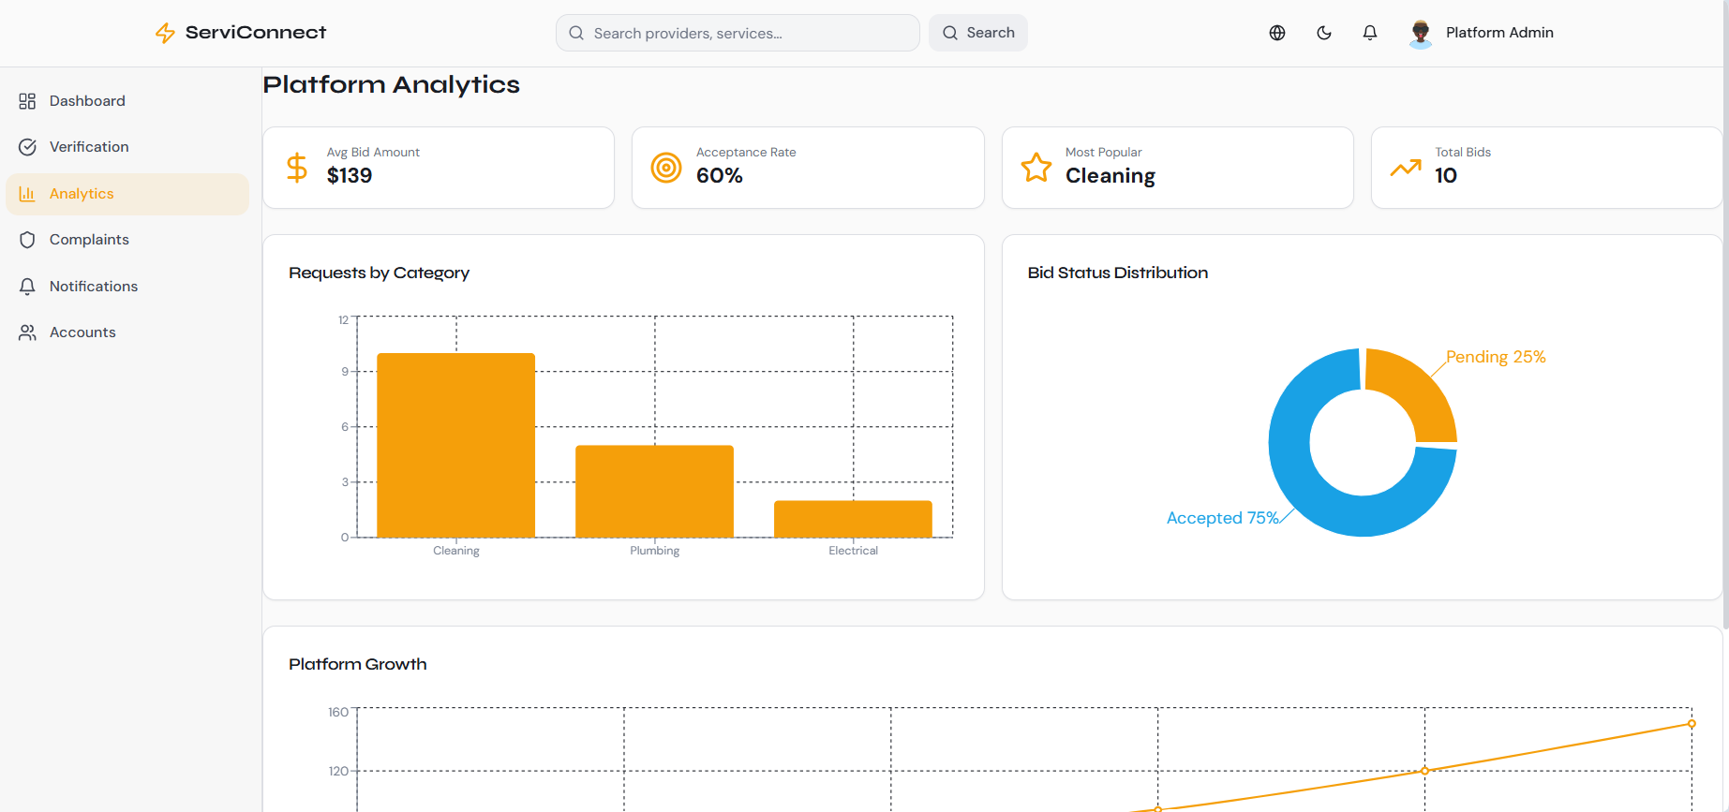
Figure 23 dashboard of Syrian Services Hub.

9.2 Comparative Analysis with Existing Systems
The benchmark study showed that existing platforms differ in their operating models. Some platforms focus mainly on ready-made services, while others focus on open service requests and competitive offers. Syrian Services Hub combines both models in one platform and adds recommendation-oriented support to improve service discovery and decision-making.
table 47 Comparative analysis between Syrian Services Hub and selected reference platforms.
Criterion | Khamsat / Fiverr | Mostaql / Upwork | Syrian Services Hub
Service model | Strong ready-made service model | Strong request and offer model | Hybrid model: services + requests + offers
User decision support | Mostly based on browsing and ratings | Based on proposals, profiles, and filters | Recommendation support plus provider comparison logic
Local adaptation | General marketplace model | General freelance/project model | Adapted to a local service marketplace context
Trust features | Ratings and profile indicators | Verification, proposals, messages | Ratings, complaints, verification, and admin control
Smart feature | Limited or implicit | Limited or platform-specific | Problem-based recommendation for solutions and providers
Knowledge-grounded customer Q&A | Generally unavailable as provider-owned cited Q&A | Generally not a core marketplace workflow | Ask Assistant retrieves provider-owned evidence and returns cited answers or an insufficient-evidence response

9.3 Achievement of Project Objectives
The achieved results can be evaluated by comparing the implemented and designed system behavior with the objectives defined at the beginning of the project. The platform succeeded in addressing the major functional areas required for a smart service marketplace, including service discovery, service request posting, offer submission, interaction, trust-related functions, and recommendation support.
table 48 Achievement of the main project objectives.
Objective | Result / Evidence | Status
Connect consumers with service providers | The system supports users, providers, services, requests, and offers. | Achieved
Support hybrid marketplace workflows | The platform includes ready-made services and open service-demand advertisements. | Achieved
Improve trust and supervision | Ratings, complaints, verification, verification revocation, and admin monitoring are supported. | Achieved
Provide intelligent recommendation support | The user enters a problem and receives suggested solutions and a recommended provider. | Achieved
Support maintainable system design | The system follows a client-server and three-tier architectural structure. | Achieved
Provide grounded customer Q&A through Ask Assistant | The system separates RAG from recommendation, retrieves authorized provider evidence, returns citations, and handles insufficient evidence safely. | Achieved

9.4 Strengths and Limitations
The project has several strengths that make it suitable as an academic software engineering solution. It combines multiple service-marketplace workflows in a unified platform, supports several user roles, and includes trust-related mechanisms that improve platform reliability. The recommendation feature also adds a smart dimension by helping users move from a problem description to suggested solutions and a suitable provider. However, the project also has limitations, especially because it was developed within an academic timeframe. Some advanced production-level features, such as full payment integration, large-scale deployment optimization, and extensive real-user evaluation, can be considered future improvements rather than core requirements of the current version.

table 49 Summary of project strengths and limitations.
Strengths | Limitations
Hybrid service marketplace model combining services, requests, and offers. | No complete online payment workflow in the current academic scope.
Clear role-based structure for visitor, user, provider, and admin. | Large-scale production deployment remains a future enhancement.
Trust mechanisms through ratings, complaints, verification, and admin control. | Recommendation quality can be improved later with more data and advanced models.
Recommendation feature supports users with suggested solutions and providers. | Usability testing with a large number of real users is still limited.
Separate RAG architecture with provider-owned knowledge, permission-aware retrieval, citations, and explicit insufficient-evidence handling. | Answer quality depends on the completeness, freshness, and clarity of provider knowledge sources and requires broader real-world evaluation.

9.5 Key Performance Indicators
Key performance indicators are used to evaluate whether the system provides acceptable quality from functional, usability, and operational perspectives. Since the project is developed in an academic context, the indicators are used mainly to guide evaluation and future improvement rather than to claim large-scale production performance.
table 50 Suggested KPIs for evaluating Syrian Services Hub.
KPI | Evaluation Focus | Expected Direction
Response time | Speed of browsing, searching, and submitting requests or offers | Fast and acceptable for normal academic testing
Requirement coverage | Coverage of functional requirements by design and test cases | High coverage for core requirements
Recommendation relevance | Suitability of suggested solutions and providers to the entered problem | Relevant recommendations for common problem descriptions
Usability | Clarity of main user paths and ease of interaction | Simple and understandable workflows
Reliability | Correct handling of roles, data, complaints, and verification status | Consistent behavior across main scenarios
RAG grounded-answer rate | Percentage of supported answers with valid citations and percentage of unsupported questions safely rejected | High citation coverage with no cross-provider evidence leakage

Chapter Ten: Conclusion and Recommendations
This chapter concludes the thesis by summarizing the main achievements, challenges, future improvements, and recommendations of Syrian Services Hub. It reflects the overall value of the platform as a structured digital marketplace supported by intelligent recommendation and RAG-based assistance.

10.1 Project Summary and Main Achievements
Syrian Services Hub was developed as a smart digital service marketplace connecting consumers and service providers through a unified platform. It supports service browsing, requests, offers, messaging, and role-based access for visitors, users, providers, and administrators.
A key achievement is the hybrid marketplace model, which combines direct service publishing with open service requests and competitive offers. Trust mechanisms include ratings, complaints, verification, administrative supervision, and verification revocation.

Table 51. Summary of Main Project Achievements
Achievement Area | Summary
Marketplace Structure | Supports ready-made services and open service requests.
Provider Interaction | Providers can publish services and submit offers.
Trust and Supervision | Ratings, complaints, verification, and administrative control improve reliability.
AI Recommendation | Suggests relevant solutions and suitable providers.
Engineering Documentation | Includes structured requirements, design, implementation, and testing.
Ask Assistant (RAG) | Provides provider-grounded answers with citations.

10.2 Difficulties and Challenges
The project faced challenges related to its broad functional scope, integration between modules, evolving requirements, documentation consistency, and limited academic time.
The intelligent features introduced additional complexity. AI Recommendation had to remain aligned with marketplace needs, while Ask Assistant required careful handling of ingestion, chunking, vector retrieval, authorization, citation integrity, and unsupported responses. These challenges were addressed through modular design, incremental development, permission-first retrieval, and grounding-focused rules.

Table 52. Main Project Challenges and Responses
Challenge | Project Response
Large functional scope | Features were prioritized and organized into modules.
Requirement refinement | Requirements and use cases were continuously reviewed.
Recommendation integration | Recommendations were linked directly to user needs.
Documentation consistency | Analysis, design, implementation, and testing were aligned progressively.
Time constraints | Development was divided into manageable phases.
RAG grounding and authorization | Retrieval was permission-controlled, citations were stored, and unsupported answers were rejected.

10.3 Future Improvements
Future development can focus on improving intelligence, usability, and scalability. AI Recommendation may be enhanced through larger datasets, machine learning, behavior analysis, and personalized ranking. Provider comparison can also be improved using ratings, response time, pricing, category, verification status, and activity history.
Additional improvements may include mobile applications, stronger notifications, multilingual support, advanced analytics, scalable deployment, performance optimization, security auditing, and operational monitoring.

Table 53. Suggested Future Improvements
Improvement | Expected Benefit
Advanced recommendation models | Improve recommendation relevance.
Enhanced provider comparison | Support better user decisions.
Mobile application support | Increase accessibility.
Advanced analytics | Improve monitoring and decision-making.
Performance and security hardening | Increase production readiness.

10.4 Recommendations
Future development should maintain a modular and requirement-driven approach, keeping core marketplace workflows stable before introducing additional complexity. Intelligent features should remain closely connected to practical user needs.
The project should also preserve traceability between requirements, design, implementation, and testing, while continuing to strengthen verification, ratings, complaints, and administrative supervision. Before production deployment, real-user testing, performance monitoring, and security assessment are recommended.

Table 54. Final Recommendations
Recommendation | Purpose
Keep core workflows simple and reliable. | Protect the main user journey.
Improve recommendation quality gradually. | Maintain useful and relevant intelligent support.
Preserve lifecycle traceability. | Support maintenance and consistency.
Strengthen trust mechanisms. | Increase confidence between users and providers.
Conduct real-user validation. | Verify usability, performance, and acceptance.
Keep AI Recommendation and Ask Assistant separate. | Maintain clear responsibility between matching and factual question answering.

Section Six: Appendices and References
Appendices
The appendices provide supporting material for the analysis, design, implementation, and testing activities discussed in the thesis. Detailed diagrams and screenshots may be inserted in their corresponding locations or attached in the appendices when preparing the final print version.

Appendix A: Detailed Use Case Diagrams.
Figure 2 Main Use Case Diagram for Syrian Services Hub
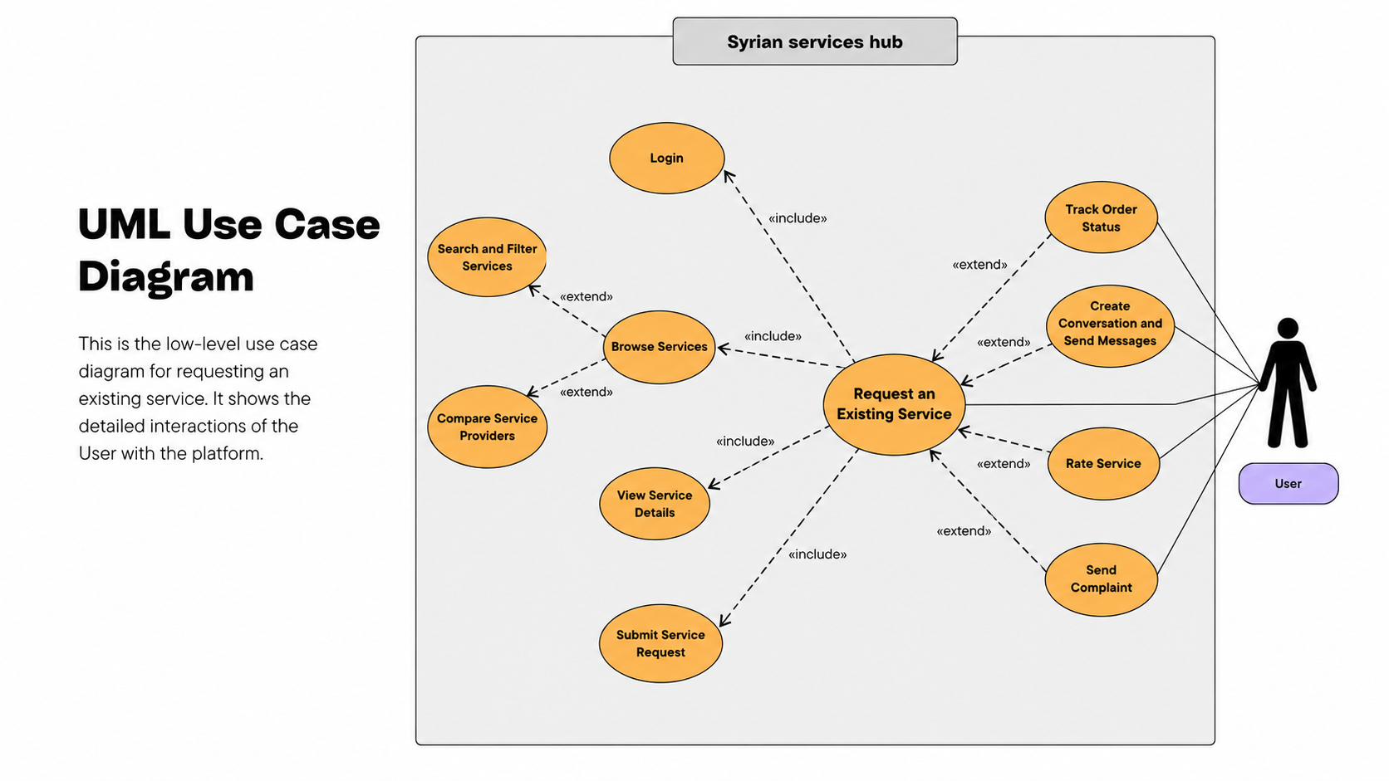
Figure 3 use cae request an exasting service
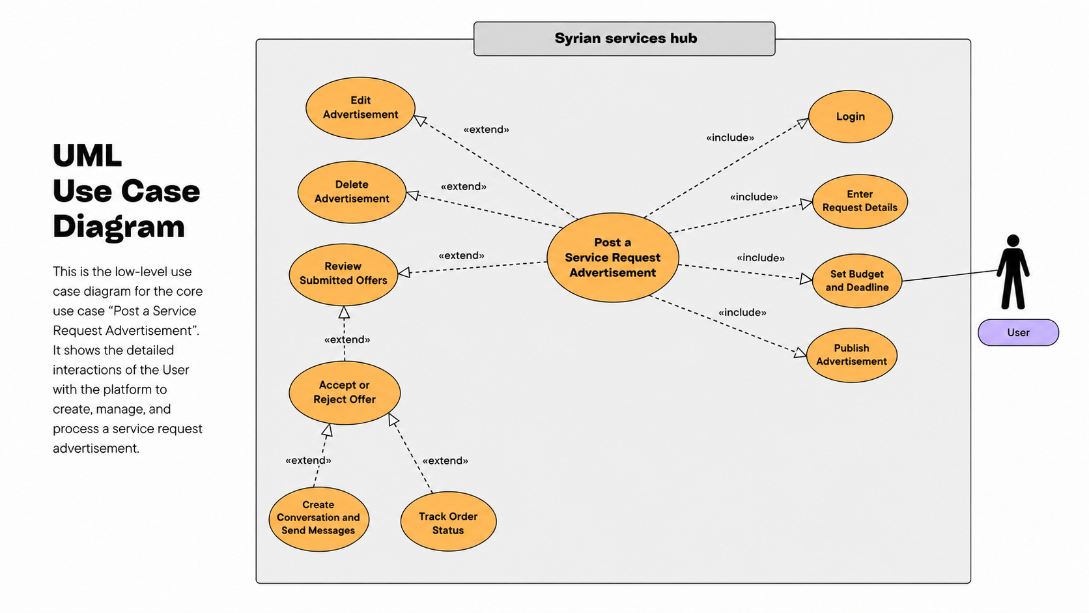
Figure 4 use cae post new request
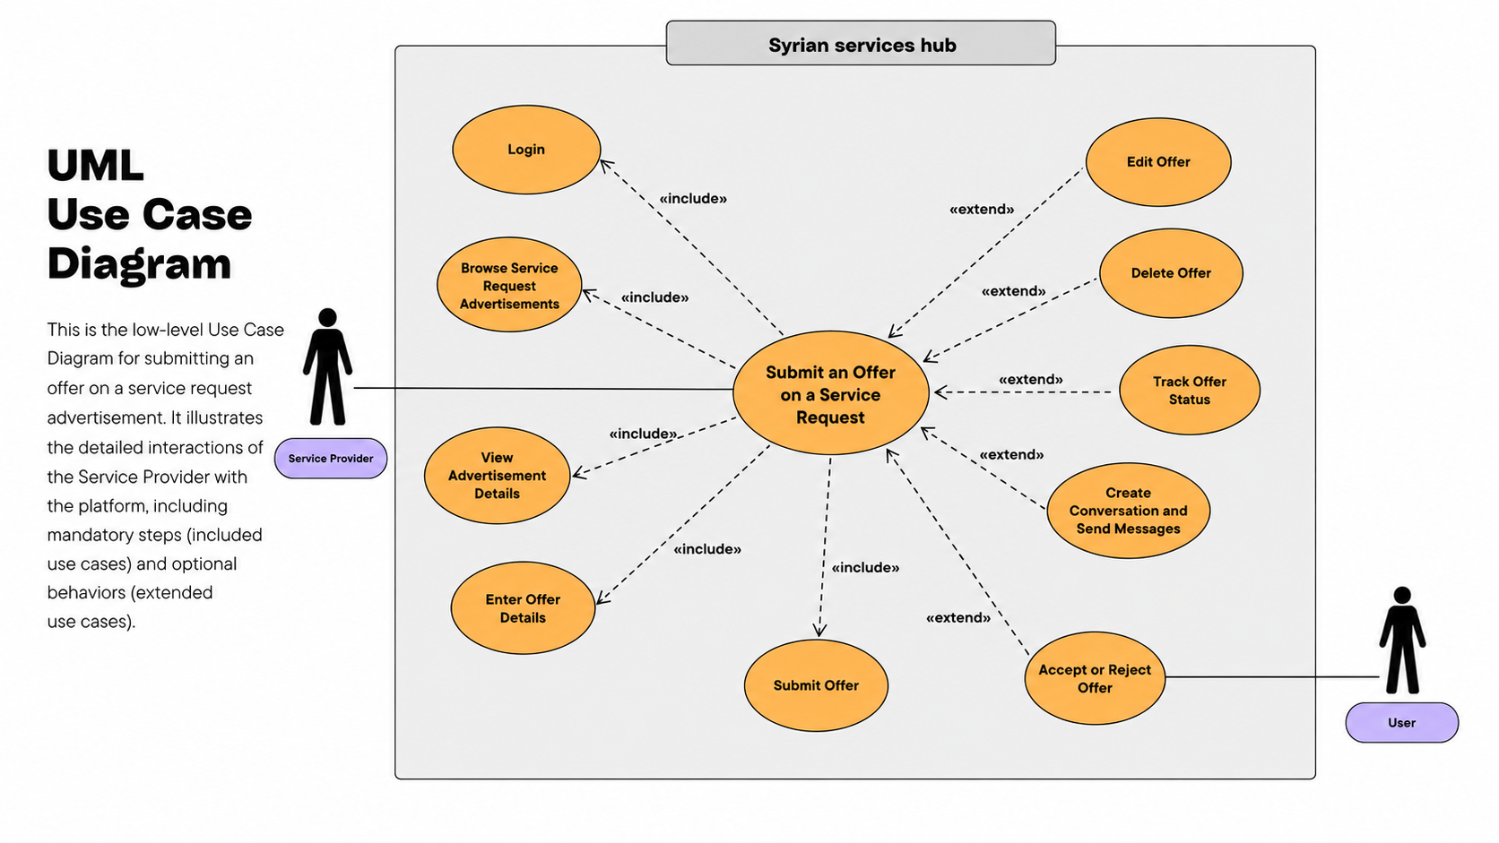
Figure 5 use case submite an offer

Appendix B: Detailed System Design

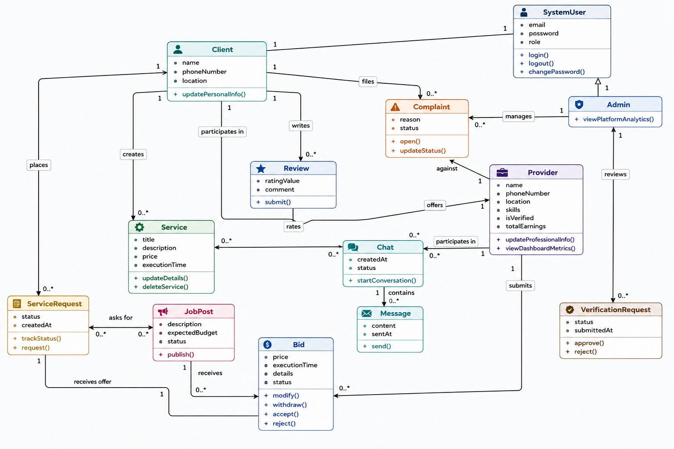
B.1 Class Diagram

B.2 Component Diagram
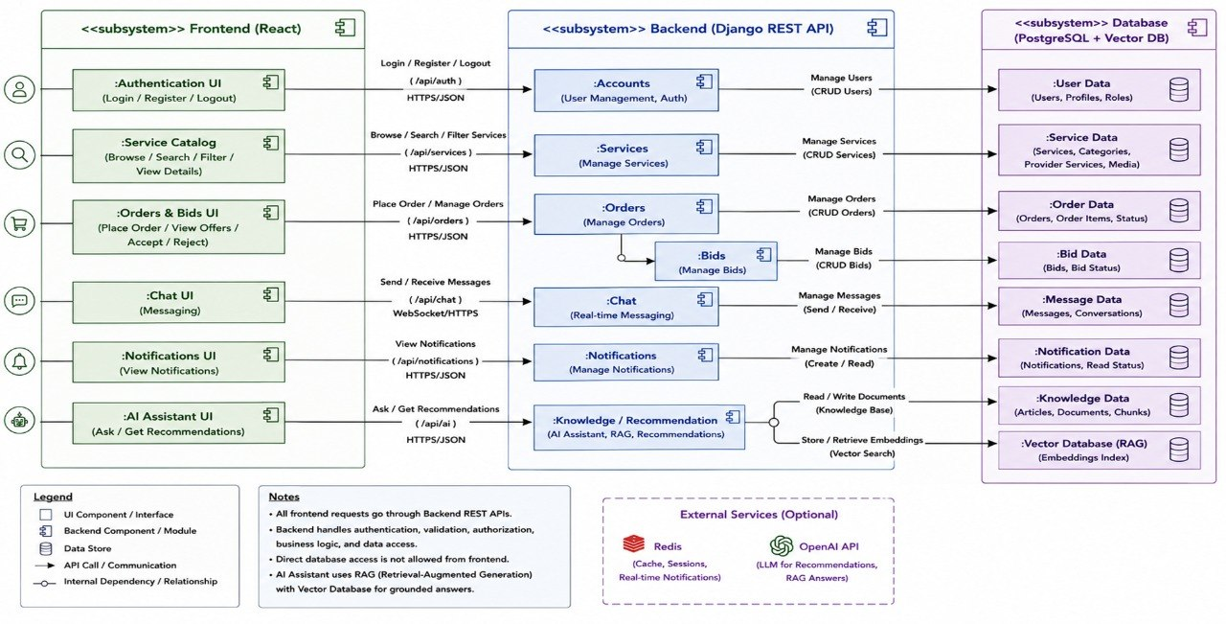

Appendix D: Ask Assistant (RAG) Technical Details

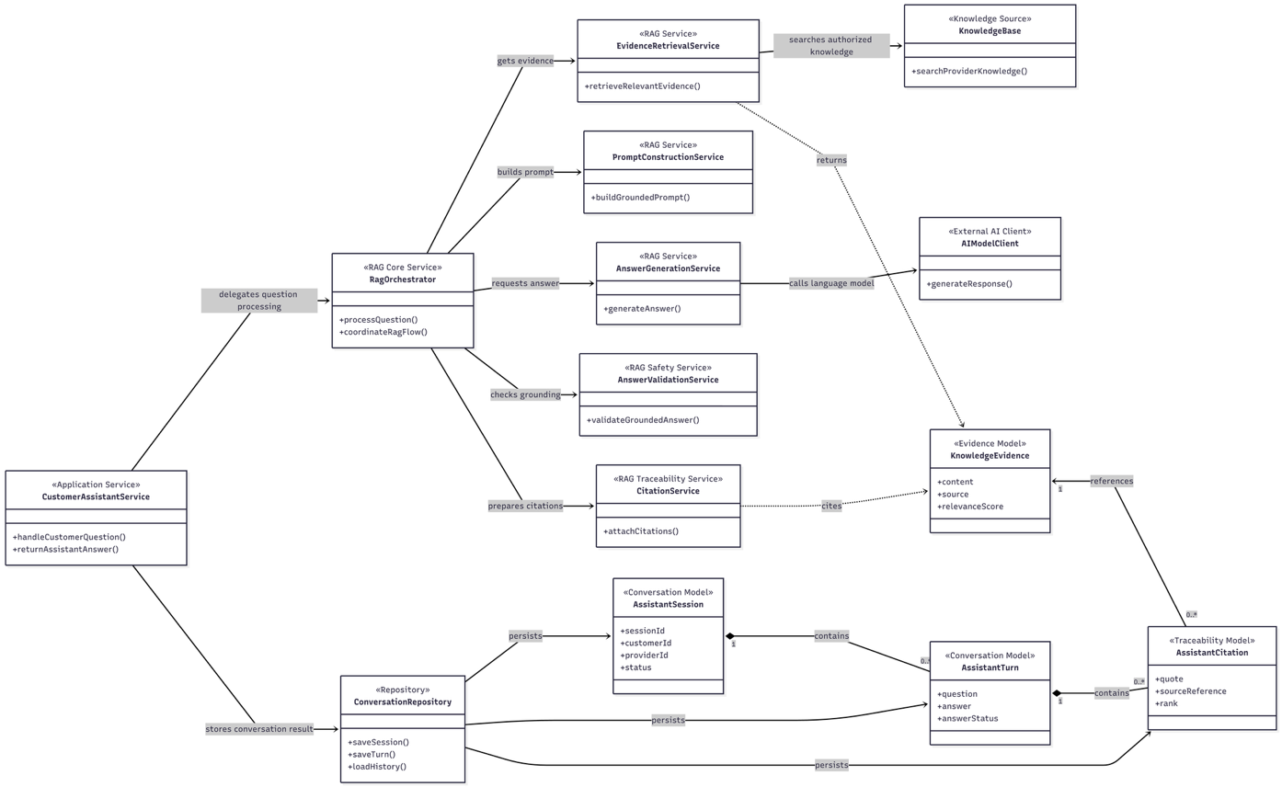
References
The following references include the official sources used in the benchmark study, the technical documentation related to the implementation stack, and the project repository used to verify implementation details. A single numbered reference style is used for consistency.
[1] Khamsat Support Center, FAQ and profile settings documentation. Available: https://support.khamsat.com/
[2] Mostaql Support Center, FAQ, completion rate, and offer package documentation. Available: https://support.mostaql.com/
[3] Fiverr Help Center, Creating a Gig and seller workflow documentation. Available: https://help.fiverr.com/
[4] Upwork Help Center, Project Catalog, proposals, direct messages, verification, and Trust and Safety resources. Available: https://support.upwork.com/
[5] Freelancer Support Center, milestone payments, KYC, and dashboard documentation. Available: https://www.freelancer.com/support/
[6] PeoplePerHour Support Center, escrow and project protection documentation. Available: https://support.peopleperhour.com/
[7] React Documentation. Available: https://react.dev/
[8] TypeScript Documentation. Available: https://www.typescriptlang.org/docs/
[9] Django Documentation. Available: https://docs.djangoproject.com/
[10] Django REST Framework Documentation. Available: https://www.django-rest-framework.org/
[11] PostgreSQL Documentation. Available: https://www.postgresql.org/docs/
[12] Vite Documentation. Available: https://vite.dev/guide/
[13] Postman Learning Center. Available: https://learning.postman.com/
[14] GitHub Documentation. Available: https://docs.github.com/
[15] Syrian Services Hub project repository. Available: https://github.com/lilasnkl/Syrian
[17] OpenAI API Documentation, Embeddings and Responses API. Available: https://platform.openai.com/docs/

